## A

## PROJECT REPORT

## ON

## VIRTUAL EXAM MANAGEMENT SYSTEM

***Submitted for the fulfillment of the Requirement for the award of the Degree of***

**M.Sc. Computer Science**

***By***

**GUDIYA KUMARI (CUSB2002312017)**

**Under the Guidance of Mr.Aditya Swarup**

**Project Manager**

**At-Codebucket Solutions Private Ltd,Patna**

***To***

**DEPARTMENT OF COMPUTER SCIENCE**

**CENTRAL UNIVERSITY OF SOUTH BIHAR**

**PANCHANPUR, GAYA, BIHAR-824236**



**CENTRAL UNIVERSITY OF SOUTH BIHAR**

**PANCHANPUR, GAYA, BIHAR-824236**

**DEPARTMENT OF COMPUTER SCIENCE**

**Certificate**

This is to certify that the project work entitled *“REAL TIME TRACKING BASED APPLICATION ON LOGISTICS MANAGEMENT-ROAD EXPRESS”* is submitted by *Gudiya Kumari*  to the Department of Computer Science, Central University of South Bihar, Gaya in partial fulfillment for the award of the degree of M.Sc. Computer Science.

We certify further that to the best of my knowledge, the project work reported herein is not a part of any other project or software on the basis of which a degree or an award was given on an earlier occasion to any other candidate.

Head of Department Internal Examine

**TRAINING CERTIFICATE**



# DECLARATION

I, Gudiya Kumari hereby declare that the project report entitled *“REAL TIME TRACKING BASED APPLICATION ON LOGISTICS MANAGEMENT-ROAD EXPRESS”* submitted by me to the Department of Computer Science, the Central University of South Bihar in partial fulfillment of the requirement for the award of the degree of M.Sc. in Computer Science is a record of bonafide project work carried out by me.

I further declare that the work reported in this project has not been submitted and will not be submitted, either in part or full, for the award of any degree or diploma in this university or any other university.

**Anjali singh**

**M.Sc. CS (2020-22)**

**CUSB2002312003**

# ACKNOWLEDGEMENT

I would like to express my special thanks to *Dr. Jainath Yadav*, Assistant Professor and Head of Department, Department of Computer Science, for providing all the necessary facilities to us and giving extra support in all matters for the successful completion of this project.

With pleasure, I also thank all the staff members of the Department of Computer Science who provide me valuable guidance during my need.

I would like to express my special thanks and gratitude to my project lead, Mr. Aditya Swarup, Project Manager at *Codebucket Solutions Private Limited* ,who gave technical support and valuable suggestions during the work ,guided us.

I am specially thanking my parents and friends who helped me a lot in finalizing this project within the limited time frame.

**Anjali Singh**

**CONTENTS**

**Abstract 7**

**Content 6**

**Synopsis 8**

**List of Abbreviations 9**

**1**  **PROBLEM STATEMENT ………………………………………………………………10**

**2 INTRODUCTION ……………………………………………………………………………11**

2.1 PROJECT OBJECTIVE ………………………………………………………………..12

2.2 PROJECT PURPOSE………………………………………………………………….12

2.3 PROJECT SCOPE …………………………………………………………………….12

**3 INTENDED AUDIENCE………………………………………………………………………….13**

**4 IMPLEMENTATION…………………………………………………………………………..13**

4.1. ROAD EXPRESS…………………………………………………………………………….13

4.2. DEVELOPMENT TOOLS………………………………………………………………….17

4.3 MODULES……………………………………………………………………………… 32

4.4 APIs SNAPSHOTS .……………………………………………………………………..37

4.5. BENEFITS …………………………………………………………………………………52

**5 PERFORMANCE REQUIREMENT………………………………………………………53**

**6 SYSTEM DESIGN AND OVERVIEW……………………………………………………54**

6.1 FLOW CHART……………………………………………………………………………54

6.2 DATABASE DESIGN………………………………………………………………………55

6.3 DATA DICTIONARY………………………………………………………………………56

6.4 INTERFACE DESIGN……………………………………………………………………..78

**7 SYSTEM FEATURE …………………........................................................................93**

7.1 SAFETY AND SECURITY REQUIREMENT………………………………………………….93

7.2 SOFTWARE QUALITY ATTRIBUTES……………………………………………………93

**8 CONCLUSION……………………………………………………………………………94**

**9**  **REFERENCES………………………………………………………………………………95**

**Annexure : USE CASE DIAGRAM ………………………………………………………….. 96**

**SYNOPSIS**

**Name of Project :**

**ROAD EXPRESS**

**Platform:**

**Operating System:**

* Microsoft Windows

**Technologies Used:**

**Mobile Platform**:Android

**Back End Platform**: NodeJS

**Testing Platform:**Postman

**User Interface Developing language**:HTML,CSS,JS

**Database**:Firebase RealTime Database,MySQL

**Application development framework**:Android

**Near Field Communication Medium:**GPS Tracker, Sim Card Tracker.

**The minimum software and hardware operating platforms are:**

**Hardware Requirement:**

RAM : MINIMUM 4GB

HARD DISK : 500 GB

INPUT DEVICES : KEYBOARD, MOUSE.

OUTPUT DEVICES : MONITOR, PRINTER.

**Software Requirement:**

OPERATING SYSTEM : WINDOWS 2010 (WINDOWS based OS)

JAVA Enabled Web-Browser.

ANDROIDS: 11.0 or Above

**LIST OF ABBREVIATIONS**

| **Abbreviation** | **Description** |
| --- | --- |
| WWW | World Wide Web |
| URL | Uniform Resource Locator |
| HTTP | Hypertext Transfer Protocol |
| RAM | Random Access Memory |
| IEEE | Institute of Electrical and Electronics Engineers |
| API | Application programming interface |
| MySQL | My Structured Query Language |
| UI | User interface |
| JSON | JavaScript Object Notation |
| GPS | Global Positioning System |
| HTML | Hypertext Markup Language |
| CSS | Cascading Style Sheets |
| NodeJS | Node JavaScript |
| NPM | Node Package Manager |
| XML | Extensible Markup Language |
| SDK | Software Development Kit |
| GUI | Graphical user interface |
| JPG | Joint Photographic Experts Group. |

**1.PROBLEM STATEMENT**

Nine groups of global problems of transport logistics have been identified, including: financial, technical, technological, information, economic, international, customs, environmental, labour. The main directions of overcoming financial, technical, technological, information, economic, international, customs, environmental and labor problems have been formulated.

Previously, Goods transportation were a challenge for all types of Businessmen as they were in bounded by the terms and condition of transporters as well as their drivers resulting unmanaged delay in transportation time which hamper the cost as well as quality of Product.Misguided transportation is also a factor of increase of cost of product and also in dilution of quality of product.

There are following problems which are faced in the transportation business.

* Due to Lack of proper delivery infrastructure
* and cost of last mile deliveries
* and Lack of Transparency
* and Poor granular tracking
* Failed Deliveries

So ,we need a sophisticated Application to perform this type of activity.

**2. INTRODUCTION**

Computers have become part of life for accessing almost any kind of information. Life in the 21st century is full of technological advancement and in this technological age it is very difficult for any organization to survive without utilizing technology. The World Wide Web contributes greatly to the creation of an ever-increasing global information database. It could also be used as a mechanism to share information within an enterprise.Logistics management is that part of the supply chain which plans, implement and control the efficient ,effective ,forward and backward (reverse) flow and storage of goods,services and information between the point of consumption in order to meet customers requirements rather to the customers delight.A professional working in the fields of logistics management is called logistician.Logistics,as a business concept, evolved only in the 1950s.This was mainly due to the increasing complexity of supplying one’s business with materials, and shipping out products in an increasingly globalized supply chain ,calling for experts in the field who are called Supply Chain Logisticians.This can be defined as having the right item in the right quantity at the right time at the right place and to the right target customers (customer), and it is the science of process having its presence in all sectors of the industry. Previously, Goods transportation were a challenge for all types of Businessmen as they were in bounded by the terms and condition of transporters as well as their drivers resulting unmanaged delay in transportation time which hamper the cost as well as quality of Product.Misguided transportation is also a factor of increase cost of product and also in dilution of quality of the product. So , we need a sophisticated Application to perform this type of activity .Our well trained and promising team always provides the best service and makes sure our customers are happy and satisfied.

We can develop an Application that is called “**Road Express** ”. “**Road Express**” Application is one of the most reputed and fast growing courier services for our client.This application acts as a connecting link between transporter , driver , customer ,field worker and other authorized persons.Our service are widely acknowledge for their features like time saving,and very efficient in use , Real time tracking facility,etc. Everyone (Client, Transporter, Driver) could able to trace / track anyone at any point of time and having a centralized monitoring body (Admin) to maintain the records of every steps performed on this application.By using this application , the process of booking of transportation ,delivery of the product to its destination, etc work becomes easy and sophisticated. So,that customer, transporter, field workers and other people easily monitor the current status of the vehicle allotment ,product loading or consignment loading and unloading location of a particular vehicle etc.

This is a user-friendly project. This is the era of information technology where automation of each and every activity is gaining importance. This application will lead to the automation of the process of “Road Express” for Booking trucks .This application will be modified and its further advanced application with more features will be released.

transportation and logistics is generally through their own fleet . In some cases , it is outsourced.Routing and scheduling software are increasingly being used for these activities.

**2.1 PROJECT OBJECTIVE:**

Previously, Goods transportation were a challenge for all types of Businessmen as they were in bounded by the terms and condition of transporters as well as their drivers resulting unmanaged delay in transportation time which hamper the cost as well as quality of Product.Misguided transportation is also a factor of increase cost of product and also in dilution of quality of the product. So , we need a sophisticated Application to perform this type of activity.Our well trained and promising team always provides the best service and makes sure our customers are happy and satisfied.

The project objectives are fairly straightforward, the first objective is that the users will be able to keep track of their current status of each and every activity that is performed by the transporter anddriver using the application “Road express' '.

The prime objective of “ROAD EXPRESS”Applicationis to develop a full-fledged Android application which could provide the easiest way to connect trace transportation to the Road Express tracking facility.

This Application is developed for unmanaged delays in transportation which hamper the cost as well as quality of product. This solution is solved through an online tracker system, which will need a “ROAD EXPRESS” for the purpose of dispatch and estimated delivery data, current location, Destination, Source and any delay information with a real time tracking facility.

**2.2 PROJECT PURPOSE :**

The main purpose of the document is to present the detailed description of this application “Road Express”. It will explain the purpose and features of this application , the interfaces of this application , what the application will do and the constraints under which it must operate. This document is intended for the transporter, driver, customer of the application and also potential developers and Admin .

**2.3 PROJECT SCOPE:**

This Application is developed for unmanaged delays in transportation which hamper the cost as well as quality of product. This solution is solved through an online tracker system, which will need a “ROAD EXPRESS” for the purpose of dispatch and estimated delivery data, current location, Destination, Source and any delay information with a real time tracking facility.

**3.INTENDED AUDIENCE**

Intended audience of this document is:-

* **Development Team**
* **Testing Team**
* **Maintenance Team**

**4.IMPLEMENTATION**

This is developed in “Java”.It uses a modular design where each and every feature is wrapped into a separate module and the modules depend on each other through well-written APIs. There are several APIs available to make plugin development easy.

Due to limited time we will be able to add only a limited number of the features to this app . There are only three main users in the group (“Customer , Transporter , Driver”) : each user has a limited knowledge on the technology to be used. This limited our ability to extend the application.

**4.1 ROAD EXPRESS :**

Road Express deliveries make up the majority of all freight that is sent as it's a great low cost way of shipping from A to B. It refers to the method of transit between the courier collection depot and courier delivery depot, as shipments are placed in cages and transported by road for this part of their journey.

Road Express transport division has been providing regular full truck loads and console services within the GCC ,state and Levant countries. Our well trained and promising team always provides the best service and makes sure our customers are happy and satisfied.

The express industry has been described as the "Business Class" of cargo services – it provides rapid, reliable and flexible delivery services on a global scale, simplifying the demands of companies world-wide.

The express industry responds to delivery requests on-demand, carrying out door-to-door transportation of goods and providing tracking information to clients en-route, and even handling customs clearance when crossing international borders.



**ROLE OF ROAD EXPRESS:**

* The express industry has been described as the "Business Class" of road express services – it provides rapid, reliable and flexible delivery services on a global scale, simplifying the demands of companies world-wide.
* Roads play a very important role in the transportation of goods for short and medium distances.
* Road transport system establishes easy contact between farms, fields, factories and markets and provides door to door service..
* In Road Express ,road transport has a huge benefit from other modes of transport, that is the flexibility which it provides. The routes and timings can be altered easily and quickly according to individual needs without much problem.
* Due to the above-mentioned advantages, road Express has become very popular and its share is constantly increasing.
* **There are some basic movement which is performed by the Road Express application :**

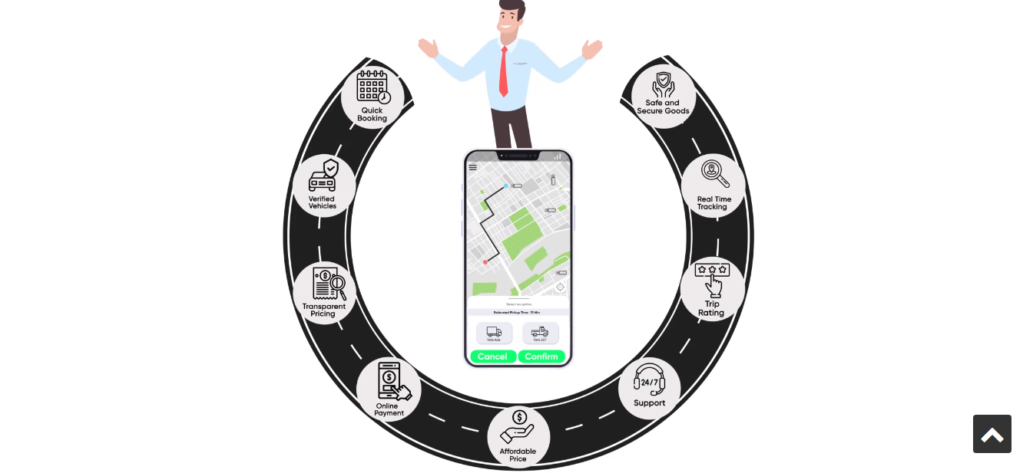

**QUICK BOOKING:**

1. Download the Road Express Partner App.
2. Client will request the transporter.
3. Transporter will accept the request of the client.
4. Go to Add Load Type and Select Load Type.
5. click the Add button.
6. Enter your Load details
7. Fill Payment details (optional) and Select Payment mode.
8. Booking Confirmation.

**VERIFIED VEHICLES:**

1 . Add Vehicles Under the Registered transporter by the Road express Partner App or directly by the Admin through the Admin dashboard.

2. Confirm vehicles booking by booking number.

**TRANSPARENT PRICING:**

Price transparency reflects the extent to which price and market information, such as bid-ask spread and depth, exist for security. In standard economic theory, market participants all have perfect information and therefore price transparency is complete.

**ONLINE PAYMENT:**

Online Payment is going through the Client Advance Payment Option under the one of the Action that is “ **Accounts**” in our Application .

In Client Advanced payment:

1. First Select Client which was paid the Advanced Payment for booking the transporter services.
2. Second ,fill the amount for paying in Advance.
3. Then ,simply Click on the Add button .
4. Now ,the Advanced Payment details will be shown in the payment category in the next option that is “Client wise” by selecting the client name.

**AFFORDABLE PRICE:**

Pricing will be adjusted by the client and driver satisfaction .In our Application there is a Rate Adjustment feature that will Adjust the price for booking the transport .

**TRIP RATING:**

Improved customer trust and confidence in your business. This is particularly important for specialist retailers as it can provide an edge over competitors who do not use customer reviews. Potential conversion rate increases due to improved trust and confidence.

**REAL TIME TRACKING:**

This will be provided the following facility:

1.Firebase real time Database

2.Sim based tracking

3.GPS tracking.

**SAVE AND SECURE GOODS:**

Save your item and securely deliver your item.

**4.2 DEVELOPMENT TOOLS :**

* **Android Platform:**

**1. Android Studio :**

The deliverable will be compiled by using Android Studio. The main reason is rather simple, simple navigation built on top of a minimal user interface which allows greater efficiency while developing this project. Besides, the software development kit (SDK) that is vital in developing mobile applications is also provided in the software so that developers will not have to look for it elsewhere. It is also quite stable as compared to other IDE such as Eclipse because the hardware requirements to run Android Studio is considerably low so it will not always crash or be unresponsive. Likewise, the features and functions contained in Android Studio are also more than enough for the current level of project development because it is a professional software that is used by millions of Android developers worldwide.

**2. Android Virtual Device & Smartphone:**

Also known as Android Emulator and a smartphone will be used as the devices to test the mobile app thoroughly throughout the project development process.

* **Back End Platform:**

**NodeJS:**

* Node.js is an open-source and cross-platform JavaScript runtime environment. It is a popular tool for almost any kind of project!
* Node.js runs the V8 JavaScript engine, the core of Google Chrome, outside of the browser. This allows Node.js to be very performant.
* A Node.js app runs in a single process, without creating a new thread for every request. Node.js provides a set of asynchronous I/O primitives in its standard library that prevent JavaScript code from blocking and generally, libraries in Node.js are written using non-blocking paradigms, making blocking behavior the exception rather than the norm.
* When Node.js performs an I/O operation, like reading from the network, accessing a database or the filesystem, instead of blocking the thread and wasting CPU cycles waiting, Node.js will resume the operations when the response comes back.
* This allows Node.js to handle thousands of concurrent connections with a single server without introducing the burden of managing thread concurrency, which could be a significant source of bugs.
* Node.js has a unique advantage because millions of frontend developers that write JavaScript for the browser are now able to write the server-side code in addition to the client-side code without the need to learn a completely different language.
* In Node.js the new ECMAScript standards can be used without problems, as you don't have to wait for all your users to update their browsers - you are in charge of deciding which ECMAScript version to use by changing the Node.js version, and you can also enable specific experimental features by running Node.js with flags.

# 

# Node.js Package Manager

Node Package Manager provides two main functionalities:

* It provides online repositories for node.js packages/modules which are searchable on search.nodejs.org
* It also provides command line utility to install Node.js packages, do version management and dependency management of Node.js packages.

The npm comes bundled with Node.js installables in versions after that v0.6.3. We can check the version by opening Node.js command prompt and typing the following command:

1. npm version 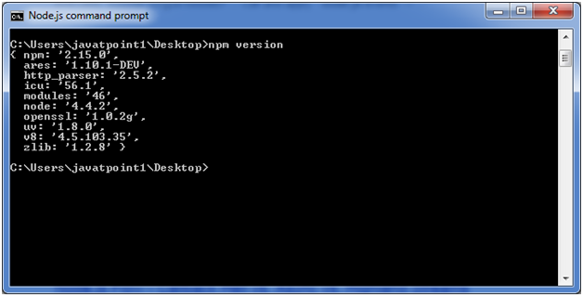

## Installing Modules using npm

Following is the syntax to install any Node.js module:

1. npm install **<Module** Name**>**

**Let's install a famous Node.js web framework called express:**

Open the Node.js command prompt and execute the following command:

1. npm install express : You can see the result after installing the "express" framework.

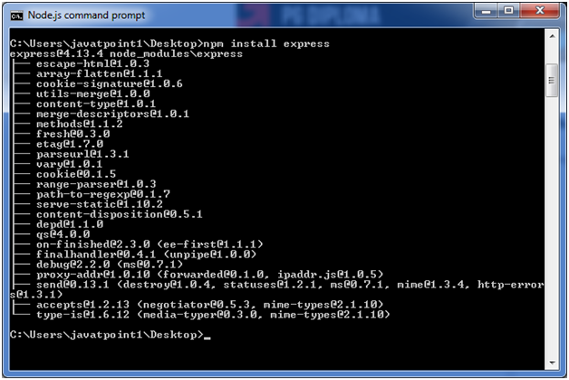

## Global vs Local Installation

By default, npm installs dependency in local mode. Here local mode specifies the folder where Node application is present. For example if you installed express module, it created node_modules directory in the current directory where it installed express module.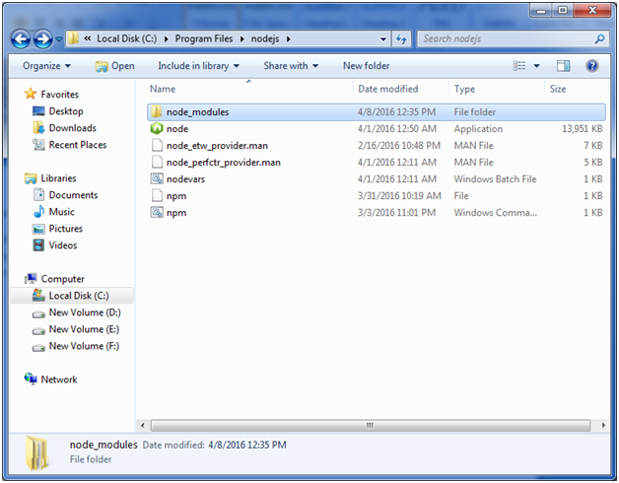

We can use the npm ls command to list down all the locally installed modules.

Open the Node.js command prompt and execute "npm ls":

Globally installed packages/dependencies are stored in the system directory. Let's install an express module using global installation. Although it will also produce the same result, modules will be installed globally.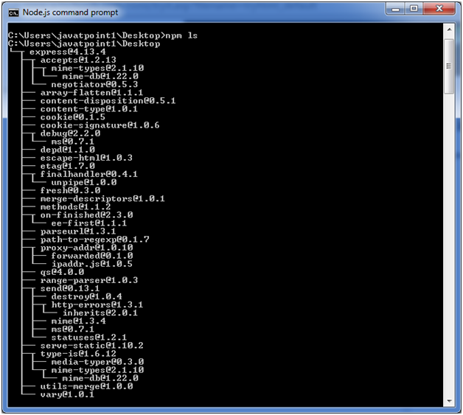

Open Node.js command prompt and execute the following code:

1. npm install express -g 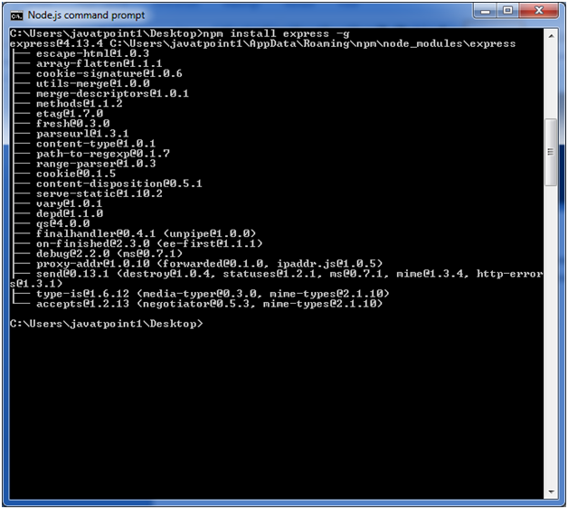

Here the first line tells about the module version and its location where it is getting installed.

# Node.js Global Objects:

Node.js global objects are global in nature and available in all modules. You don't need to include these objects in your application; rather they can be used directly. These objects are modules, functions, strings and objects etc. Some of these objects aren't actually in the global scope but in the module scope.

A list of Node.js global objects are given below:

* __dirname
* __filename
* Console
* Process
* Buffer
* setImmediate(callback[, arg][, ...])
* setInterval(callback, delay[, arg][, ...])
* setTimeout(callback, delay[, arg][, ...])
* clearImmediate(immediateObject)
* clearInterval(intervalObject)
* clearTimeout(timeoutObject)

## A Vast Number of Libraries

npm with its simple structure helped the ecosystem of Node.js proliferate, and now the npm registry hosts over 1,000,000 open source packages that can be freely used.

* **Testing Platform:**

Postman is one of the most popular software testing tools which is used for API testing. With the help of this tool, developers can easily create, test, share, and document APIs.

## Postman

* Postman is a standalone software testing API (Application Programming Interface) platform to build, test, design, modify, and document APIs. It is a simple Graphic User Interface for sending and viewing HTTP requests and responses.
* While using Postman, for testing purposes, one doesn't need to write any HTTP client network code. Instead, we build test suites called collections and let Postman interact with the API.
* In this tool, nearly any functionality that any developer may need is embedded. This tool has the ability to make various types of HTTP requests like GET, POST, PUT, PATCH, and convert the API to code for languages like JavaScript and Python.

**Terminologies Related to Postman:**

**API**

Application Programming Interface (API) is software that acts as an intermediary for two apps to communicate with each other. We use APIs whenever we use an application like Twitter, Facebook, sending text messages, or checking the weather over the phone.

### HTTP

HTTP (Hypertext Transfer Protocol) is the collection of rules for the transmission of data on the World Wide Web, like graphic images, text, video, sound, and other multimedia data. The Web users implicitly make use of HTTP as soon as they open their Web browser.

Example: A user or browser enters the HTTP request to the server; the server then returns the user response. This response includes the request status information and may consist of the requested material as well.

The most commonly used HTTP methods are GET, POST, PUT, PATCH, HEAD, DELETE, and OPTIONS.

## Why use Postman?

Postman is based on a wide range of extremely user-friendly power tools. For more than 8 million users, Postman has become a tool of convenience. Following are the reasons why Postman is used:

**Accessibility-** One can use it anywhere after installing Postman into the device by simply logging in to the account.

**Use Collections**-Postman allows users to build collections for their API-calls. Every set can create multiple requests and subfolders. It will help to organize the test suites.

**Test development-** To test checkpoints, verification of successful HTTP response status shall be added to every API- calls.

**Automation Testing-**Tests can be performed in several repetitions or iterations by using the Collection Runner or Newman, which saves time for repeated tests.

**Creating Environments-** The design of multiple environments results in less replication of tests as one can use the same collection but for a different setting.

**Debugging-** To effectively debug the tests, the postman console helps to track what data is being retrieved.

**Collaboration-** You can import or export collections and environments to enhance the sharing of files. You may also use a direct connection to share the collections.

**Continuous integration-**It can support continuous integration.

* **Google Maps API :**

One of the modules in the project uses Google Maps API as a tool to build up the functionality of the module. This API enables the developers to display maps in Android, IOS, as well as websites through a randomly generated API key. It also offers plenty of features to the developers in order to meet their development needs. After implementing Google Maps API, the device's location can be determined by using built-in GPS and configurations in the applications code.

* **Google Maps Directions API :**

This API is a service that calculates directions between locations while it enables the users to search for directions for several modes of transportation, including transit, driving, walking, or cycling (Google Developers, 2017).

* **User Interface Developing language**:

**HTML:**

HTML is an acronym which stands for **Hyper Text Markup Language** which is used for creating web pages and web applications. Let's see what is meant by Hypertext Markup Language, and Web page.

**HyperText:** HyperText simply means "Text within Text." A text has a link within it, is a hypertext. Whenever you click on a link which brings you to a new webpage, you have clicked on a hypertext. HyperText is a way to link two or more web pages (HTML documents) with each other.

**Markup language:** A markup language is a computer language that is used to apply layout and formatting conventions to a text document. Markup language makes text more interactive and dynamic. It can turn text into images, tables, links, etc.

**Web Page:** A web page is a document which is commonly written in HTML and translated by a web browser. A web page can be identified by entering an URL. A Web page can be of the static or dynamic type. **With the help of HTML only, we can create static web pages**.

Hence, HTML is a markup language which is used for creating attractive web pages with the help of styling, and which looks in a nice format on a web browser. An HTML document is made of many HTML tags and each HTML tag contains different content.

**Let's see a simple example of HTML.**

1. <!DOCTYPE**>**
2. **<html>**
3. **<head>**
4. **<title>**Web page title**</title>**
5. **</head>**
6. **<body>**
7. **<h1>**Write Your First Heading**</h1>**
8. **<p>**Write Your First Paragraph.**</p>**
9. **</body>**
10. **</html>**

## Description of HTML Example

**<!DOCTYPE>:** It defines the document type or it instruct the browser about the version of HTML.

**<html >** :This tag informs the browser that it is an HTML document. Text between html tag describes the web document. It is a container for all other elements of HTML except <!DOCTYPE>

**<head>:** It should be the first element inside the <html> element, which contains the metadata(information about the document). It must be closed before the body tag opens.

**<title>:** As its name suggested, it is used to add title of that HTML page which appears at the top of the browser window. It must be placed inside the head tag and should close immediately. (Optional)

**<body>** : Text between body tags describes the body content of the page that is visible to the end user. This tag contains the main content of the HTML document.

**<h1>** : Text between <h1> tag describes the first level heading of the webpage.

**<p>** : Text between <p> tag describes the paragraph of the webpage.

**Brief History of HTML:**

In the late 1980's , a physicist, Tim Berners-Lee who was a contractor at CERN, proposed a system for CERN researchers. In 1989, he wrote a memo proposing an internet based hypertext system.

**Tim Berners-Lee** is known as the father of HTML. The first available description of HTML was a document called "HTML Tags" proposed by Tim in late 1991. The latest version of HTML is HTML5, which we will learn later in this tutorial.

## HTML Versions

Since the time HTML was invented there are lots of HTML versions in market, the brief introduction about the HTML version is given below:

**HTML 1.0:** The first version of HTML was 1.0, which was the barebones version of HTML language, and it was released in1991.

**HTML 2.0:** This was the next version which was released in 1995, and it was the standard language version for website design. HTML 2.0 was able to support extra features such as form-based file upload, form elements such as text box, option button, etc.

**HTML 3.2:** HTML 3.2 version was published by W3C in early 1997. This version was capable of creating tables and providing support for extra options for form elements. It can also support a web page with complex mathematical equations. It became an official standard for any browser till January 1997. Today it is practically supported by most of the browsers.

**HTML 4.01:** HTML 4.01 version was released in December 1999, and it is a very stable version of HTML language. This version is the current official standard, and it provides added support for stylesheets (CSS) and scripting ability for various multimedia elements.

**HTML5 :** HTML5 is the newest version of HyperText Markup language. The first draft of this version was announced in January 2008. There are two major organizations one is W3C (World Wide Web Consortium), and another one is WHATWG( Web Hypertext Application Technology Working Group) which are involved in the development of the HTML 5 version, and still, it is under development.

**CSS:**

CSS stands for **Cascading Style Sheets**. It is a style sheet language which is used to describe the look and formatting of a document written in markup language. It provides an additional feature to HTML. It is generally used with HTML to change the style of web pages and user interfaces. It can also be used with any kind of XML documents including plain XML, SVG and XUL.

CSS is used along with HTML and JavaScript in most websites to create user interfaces for web applications and user interfaces for many mobile applications.

## Why use CSS

These are the three major benefits of CSS:

## 1) Solves a big problem

Before CSS, tags like font, color, background style, element alignments, border and size had to be repeated on every web page. This was a very long process. For example: If you are developing a large website where fonts and color information are added on every single page, it will become a long and expensive process. CSS was created to solve this problem. It was a W3C recommendation.

## 2) Saves a lot of time

CSS style definitions are saved in external CSS files so it is possible to change the entire website by changing just one file.

## 3) Provide more attributes

CSS provides more detailed attributes than plain HTML to define the look and feel of the website.

**JS:(JAVA SCRIPT)**

JavaScript (js) is a light-weight object-oriented programming language which is used by several websites for scripting the webpages. It is an interpreted, full-fledged programming language that enables dynamic interactivity on websites when applied to an HTML document. It was introduced in the year 1995 for adding programs to the webpages in the Netscape Navigator browser. Since then, it has been adopted by all other graphical web browsers. With JavaScript, users can build modern web applications to interact directly without reloading the page every time. The traditional website uses js to provide several forms of interactivity and simplicity.

Although, JavaScript has no connectivity with Java programming language. The name was suggested and provided in the times when Java was gaining popularity in the market. In addition to web browsers, databases such as CouchDB and MongoDB use JavaScript as their scripting and query language.

## Features of JavaScript

There are following features of JavaScript:

1. All popular web browsers support JavaScript as they provide built-in execution environments.
2. JavaScript follows the syntax and structure of the C programming language. Thus, it is a structured programming language.
3. JavaScript is a weakly typed language, where certain types are implicitly cast (depending on the operation).
4. JavaScript is an object-oriented programming language that uses prototypes rather than using classes for inheritance.
5. It is a light-weighted and interpreted language.
6. It is a case-sensitive language.
7. JavaScript is supportable in several operating systems including, Windows, macOS, etc.
8. It provides good control to the users over the web browsers.

## History of JavaScript

In 1993, **Mosaic**, the first popular web browser, came into existence. In the **year 1994**, **Netscape** was founded by **Marc Andreessen**. He realized that the web needed to become more dynamic. Thus, a 'glue language' was believed to be provided to HTML to make web designing easy for designers and part-time programmers. Consequently, in 1995, the company recruited **Brendan Eich** intending to implement and embed Scheme programming language to the browser. But, before Brendan could start, the company merged with **Sun Microsystems** for adding Java into its Navigator so that it could compete with Microsoft over the web technologies and platforms. Now, two languages were there: Java and the scripting language. Further, Netscape decided to give a similar name to the scripting language as Java's. It led to 'Javascript'. Finally, in May 1995, Marc Andreessen coined the first code of Javascript named '**Mocha**'. Later, the marketing team replaced the name with '**LiveScript**'. But, due to trademark reasons and certain other reasons, in December 1995, the language was finally renamed to 'JavaScript'. From then, JavaScript came into existence.

## Application of JavaScript

JavaScript is used to create interactive websites. It is mainly used for:

* Client-side validation,
* Dynamic drop-down menus,
* Displaying date and time,
* Displaying pop-up windows and dialog boxes (like an alert dialog box, confirm dialog box and prompt dialog box),
* Displaying clocks etc.
* **Database**

**FIREBASE REALTIME DATABASE:**

The Firebase Realtime Database is a cloud-hosted database in which data is stored as JSON. The data is synchronized in real-time to every connected client. All of our clients share one Realtime Database instance and automatically receive updates with the newest data, when we build cross-platform applications with our iOS, and JavaScript SDKs.

The Firebase Realtime Database is a NoSQL database from which we can store and sync the data between our users in real-time. It is a big JSON object which the developers can manage in real-time. By using a single API, the Firebase database provides the application with the current value of the data and updates to that data. Real-time syncing makes it easy for our users to access their data from any device, be it web or mobile.

The Realtime database helps our users collaborate with one another. It ships with mobile and web SDKs, which allow us to build our app without the need for servers. When our users go offline, the Real-time Database SDKs use local cache on the device for serving and storing changes. The local data is automatically synchronized, when the device comes online.

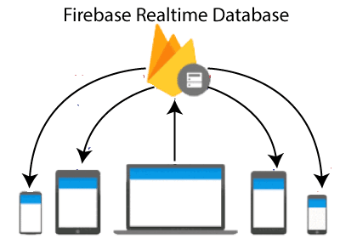

## Key capabilities

A Real-time database is capable of providing all offline and online services. These capabilities include accessibility from the client device, scaling across multiple databases, and many more.

### Real-time

The Firebase Real-time database uses data synchronization instead of using HTTP requests. Any connected device receives the updates within milliseconds. It doesn't think about network code and provides collaborative and immersive experiences.

### Offline

The Firebase Database SDK persists our data to disk, and for this reason, Firebase apps remain responsive even when offline. The client device receives the missed changes, once connectivity is re-established.

### Accessible from client devices

There is no need for an application server to access the Firebase Real-time database. We can access it directly from a mobile device or web browser. Data validation and security are available through the Firebase Real-time Database Security Rules, expression-based rules executed when data is read or written.

### Scaling across multiple databases

With the Firebase Real-time Database on Blaze Pricing Plan, we can support the data needs of our app by splitting our data across multiple database instances in a single Firebase project. Streamline authentication with Firebase authentication on our project and authenticate users in our database instances. Controls access to data in each database with custom Firebase real-time database rules available for each database instance.

## Other Alternatives

Apart from Firebase's real-time database, there are several alternatives that are used.

### Cloud Firestore

Cloud Firestore is a scalable and flexible database used for server development, mobile, and web from Firebase and Google Cloud Platform.

### Firebase Remote Config

It stores developer specified key-value pairs to change the behavior and appearance of our app without requiring users to download an update.

### Firebase Hosting

It is used to host the HTML, CSS, and JavaScript of our website as well as other developer-provided assets like graphing, fonts, and icons.

### Cloud Storage

It is used to store images, videos, and audio as well as other user-generated content.

**MYSQL DATABASE:**

MySQL is currently the most popular database management system software used for managing the relational database. It is open-source database software, which is supported by Oracle Company. It is fast, scalable, and an easy to use database management system in comparison with Microsoft SQL Server and Oracle Database. It is commonly used in conjunction with PHP scripts for creating powerful and dynamic server-side or web-based enterprise applications.

It is developed, marketed, and supported by **MySQL AB, a Swedish company**, and written in C programming language and C++ programming language. The official pronunciation of MySQL is not the My Sequel; it is **My Ess Que Ell**. However, you can pronounce it your way*.* Many small and big companies use MySQL. MySQL supports many Operating Systems like Windows, Linex, MacOS, etc. with C, C++, and java languages.

MySQL is a Relational Database Management System (RDBMS) software that provides many things, which are as follows:

* It allows us to implement database operations on tables, rows, columns, and indexes.
* It defines the database relationship in the form of tables (collection of rows and columns), also known as relations.
* It provides the Referential Integrity between rows or columns of various tables.
* It allows us to update the table indexes automatically.
* It uses many SQL queries and combines useful information from multiple tables for the end-users.

**Working:**

MySQL follows the working of Client-Server Architecture. This model is designed for the end-users called clients to access the resources from a central computer known as a server using network services. Here, the clients make requests through a graphical user interface (GUI), and the server will give the desired output as soon as the instructions are matched. The process of the MySQL environment is the same as the client-server model.

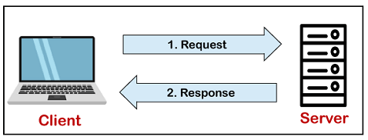

The core of the MySQL database is the MySQL Server. This server is available as a separate program and responsible for handling all the database instructions, statements, or commands. The working of MySQL database with MySQL Server are as follows:

1. MySQL creates a database that allows you to build many tables to store and manipulate data and define the relationship between each table.
2. Clients make requests through the GUI screen or command prompt by using specific SQL expressions on MySQL.
3. Finally, the server application will respond with the requested expressions and produce the desired result on the client-side.

A client can use any MySQL GUI. But, it is making sure that your GUI should be lighter and user-friendly to make your data management activities faster and easier. Some of the most widely used MySQL GUIs are MySQL Workbench, SequelPro, DBVisualizer, and the Navicat DB Admin Tool. Some GUIs are commercial, while some are free with limited functionality, and some are only compatible with MacOS. Thus, you can choose the GUI according to your needs.

## Reasons for popularity

MySQL is becoming so popular because of these following reasons:

* MySQL is an open-source database, so you don't have to pay a single penny to use it.
* MySQL is a very powerful program that can handle a large set of functionality of the most expensive and powerful database packages.
* MySQL is customizable because it is an open-source database, and the open-source GPL license facilitates programmers to modify the SQL software according to their own specific environment.
* MySQL is quicker than other databases, so it can work well even with a large data set.
* MySQL supports many operating systems with many languages like PHP, PERL, C, C++, JAVA, etc.
* MySQL uses a standard form of the well-known SQL data language.
* MySQL is very friendly with PHP, the most popular language for web development.
* MySQL supports large databases, up to 50 million rows or more in a table. The default file size limit for a table is 4GB, but you can increase this (if your operating system can handle it) to a theoretical limit of 8 million terabytes (TB).

**4.3 MODULES:**

The software is made up with four module :

* Admin Dashboard Module
* Client Dashboard Module
* Driver Module
* Transporter Module

The functionality of each module is as follows:

* **Admin Dashboard Module:**

The admin module will manage the overall process for both Apps ( that is “Road Express partner App”(which is transporter app), “Road Express Hero App (which is driver app”)) Managed by the dashboard Admin which is web based application .It maintains all details regarding the activities and functionalities of Transporter , Driver and customer. Admin will store each and every process and maintain the database regarding that . The Admin should be highly experienced for this work.

Is having five Individual Actions:

* + OPERATION
  + ACCOUNT
  + SURVEILLANCE
  + RATE ADJUSTMENT
  + SIM BASED TRACKING

Each Action consists of several processes that are as follows:

* OPERATION:
  + - Add Transporter
    - Add Driver
    - Add Vehicles
    - Add city Management
    - Add Load /Product type
    - Map Driver
    - Placement Sheet update
    - Add trip
    - Master OTP
* **Add Transporter:**

We can easily add the transporter by the admin and maintain corresponding details regarding the transporter .The details will be maintained in the transporter table in addition to the Transporter operation .

**Transporter Table** has functionality to download details of every Transporter in Excel / CSV file format and is able to Edit some Basic Information of Transporter.

* **Add Driver:-**

In Add Driver operation, we can easily add the Driver by the admin.

➢ There are three section which is mention in Add Driver Operation:

● Add Driver.

● Validate Driver.

● Validated Driver.

Add Driver:-

Select Transporter (Drop Down Containing all Transporter Added)

Name (Legal Name)

State (Drop Down Select)

City (Drop Down Select)

Mobile Number (10 Digits)

Birthday (As on Aadhar Card)

D.L. Expiration Date (Driving License Expiration Date)

Password (Minimum 8 Digits and Alphanumeric)

Profile Picture (in JPEG file format)

Driver’s License Front Picture (in JPEG file format)

Driver’s License Back Picture (in JPEG file format)

Aadhar Front Picture (in JPEG file format)

Aadhar Back Picture (in JPEG file format)

After providing these details, Admin will add a Driver which will be allocated in the Validate Driver Table.

**Validate Driver:-**

In validate Driver ,After Add Driver store Details in Unverified Table.

**Validate Driver Table** has functionality to download details of every Driver in Excel / CSV file format and Admin Authority to Validate Driver after reviewing the provided details.

**After** Validation, the Driver will finally be visible in the Validated Driver Table.

**Validated Drivers** profiles could be Editable & Viewable.

* **Add Vehicle**:
* In Add Vehicle , providing some basic details regarding vehicles under selected registered transporters by the Admin.
* Admin will add vehicles that will enlist under the All Vehicles Table.
* **All Vehicles** Table has functionality to download details of every Vehicles in Excel / CSV file format and Admin Authority to Validate Vehicle after reviewing the provided details and able to Edit some Basic Details as well as able to View full profile.
* **Add City :**
* Here we can easily add a new city for transporting business.

In Add City operation,there are two fields:-

● State

● City

* Here City should be New (which has not registered already).

State Name (Drop Down Select)

City

* **Add Load Type :**
* In Add Load Type Operation , we can easily add the load type through the client by the admin .
* After Adding the Load Type ,the load type will be added to the list .
* **Placement Sheet Update** -

Could be Categorized using:

* Trip Starting Date &
* Trip Ending Date

Will provide all Trip related information.

Admin will act (Book) according to needs and availability.

Admin could Cancel any Booking (if misconduct or mismanagement happens)

After Clicking **BOOK option**, Admin will map specific Transporter after validating the **Load Check**

Post Details by clicking on the **BOOK NOW** option.

* **Map Driver :**

Here We can map the driver to the registered transporter then mapping is confirmed by the transporter.

* **Add Trip :**

Here , we can easily add the trip and see the details in trip history .

* **Add Client / Company :**

Here the admin will directly add the client by filling some personal details and its demanding list.

* **Update Master OTP :**

· This is a Super OTP which could Bypass the Authentication process, if the user is facing any problem related to OTP Verification.

* **Clients :**

Section will show all Clients as well as their respective details Serially as enlisted below: -

**Name, City, State, Mobile, Email, Designation, Surge Charge, G.S.T. Number, Rate Matrix Type, Wait Charge, Profile Pic, Edit Option.**

* ACCOUNT:

In Account operation there will be manage the account according to Client Wise,Driver wise and Transporter wise.

* There are available four operations:
* Client wise
* Transport wise
* Driver wise

**➢ Client Wise :**

● Select Client (Drop Down)

After selection, Three separate options will be displayed:

● **Trip Wise -** All trips performed for any particular client will be enlisted here.

● **Payment -** Payment Related Information (Advance Payment) will be enlisted here.

● **Ledger** - All Payment related Information (Payment History, Advance Payment, Total Balance)

will be enlisted here.

**➢ Client Advance Payment :**

● Select Client (Drop Down)

● Enter Advance Payment Amount (Input Box)

● Mode Of Payment(Cash, Cheque, Online) (Dropdown)

If Cheque (Provide Cheque Number)

If Online (Provide Transaction ID)

Then store advance payment in the Client wise Payment section.

**➢ Transporter Wise :**

● Select Client (Drop Down)

After selection, Two separate options will be displayed:

● Trip Wise - All trips performed for any particular client will be enlisted here.

● Ledger - All Payment related Information (Payment History, Advance Payment, Total Balance)

will be enlisted here.

**➢ Driver Wise :**

● Select Client (Drop Down)

After selection, One option will be displayed:

**● Trip Wise -** All trips performed for any particular client will be enlisted here.

* SURVEILLANCE:
* In this Section, there are four (That is- Incoming, Outgoing, Trip,Trip History,Trips) operations active but First two operations are Geo Tracking Based as Admin will only provide the District name (Drop Down) and according to the selected district, Google Map will be shown.
* RATE ADJUSTMENT:

In this Section, there are three operations (i.e. Vehicle,Client and Dynamic Rate) :

* **By Vehicle(Vehicle rate):**

In vehicle operation firstly select vehicle type then update vehicle rate according to selected vehicle.

* **By Client(Client rate):**

Here in this client operation we will choose Client and Vehicle then update Client rate and Driver rate according to selected Client and Vehicle.

* **By Dynamic(Dynamic rate):**

In this operation, we will choose Vehicle,State and City then update the Rate for fulfilling the required field.

* Range
* Rate/km
* Base Fare
* Wait charge
* Max free wait time/in minutes

according to selected Vehicle,State and City.

* SIM BASED TRACKING:

Here we can easily track the location of trucks through the phone number.

* **Client Dashboard Module:**

The client module will manage the overall process regarding client activity , by the Client dashboard which is a web based application . Clients will store the information regarding each and every process and maintain the database regarding that(booking transport and themselves).

* + Transporter manage the following criteria:-
* Manage Driver.
* Manage Rate Adjustment .
* Manage simBasedTracking.

* **Transporter Module:**

The Transporter module provides a facility for booking services and tracking (GPS Tracker or Real time tracking facility) through track number provides the easiest way to connect trace transportation to track Road Express tracking facility.

* + Transporter manage the following criteria:-
* Manage transporter.
* Manage trip .
* Manage Rate Adjustment
* Manage Sim Based Tracking.
* **Driver Module**

The Driver module provides a facility for Registering themselves by using RoadExpress Hero App(Driver App) and also communicating with Transporter and Driver.

* + Driver manage the following criteria:-
* Manage Driver. .
* Manage Rate Adjustment
* Manage simBasedTracking

**4.4. API SNAPSHOTS :**

* Login And Add Transporter by POST request:

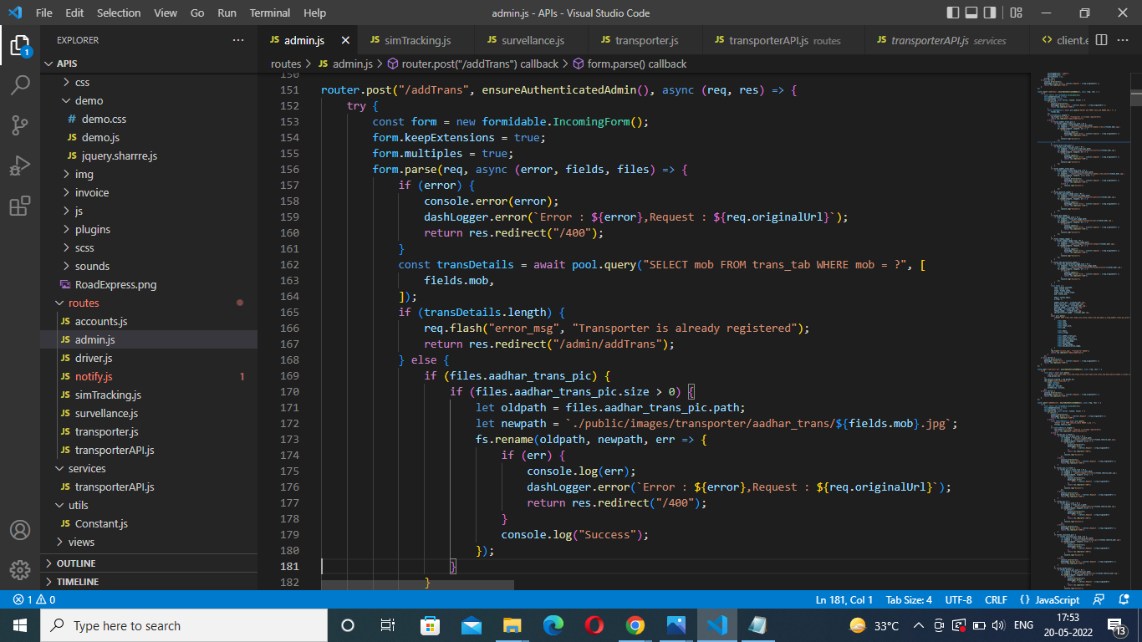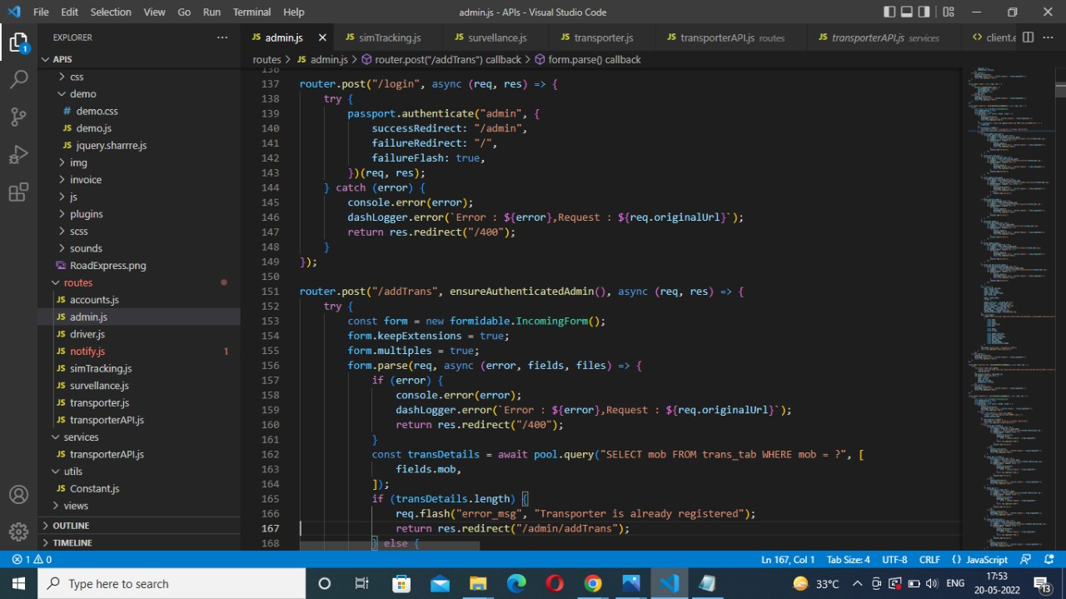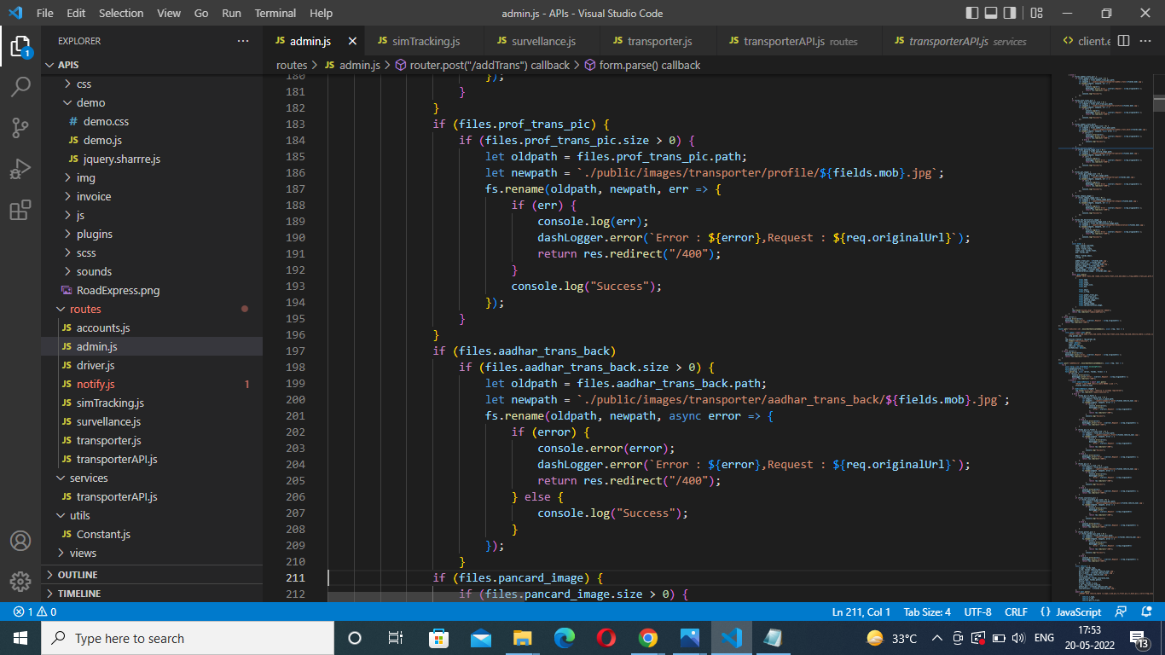

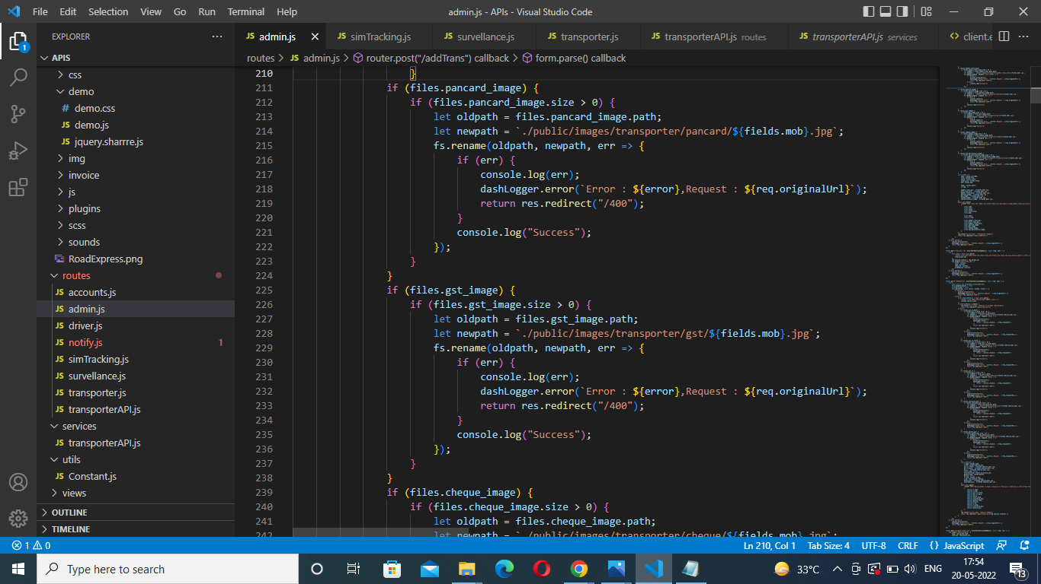

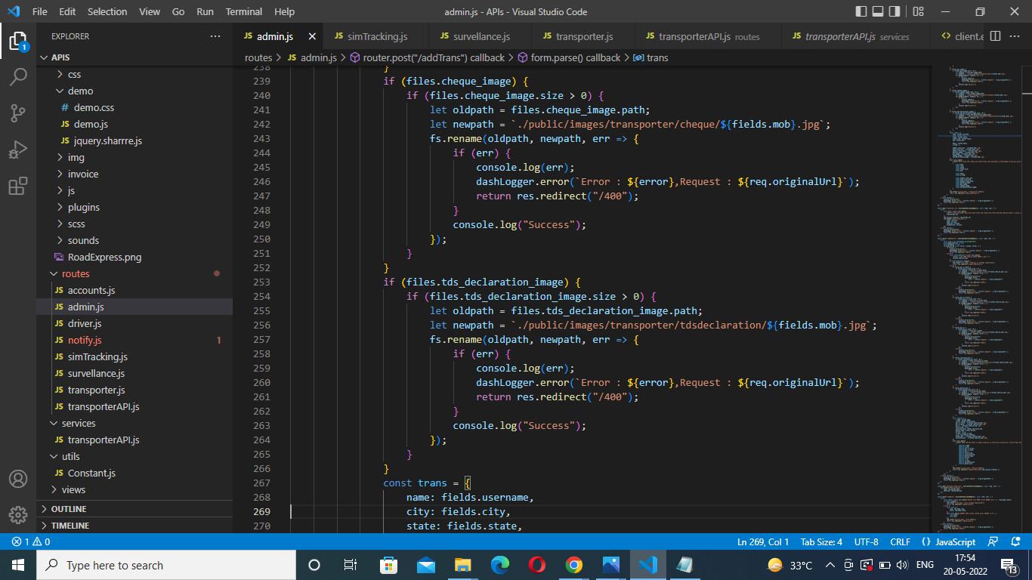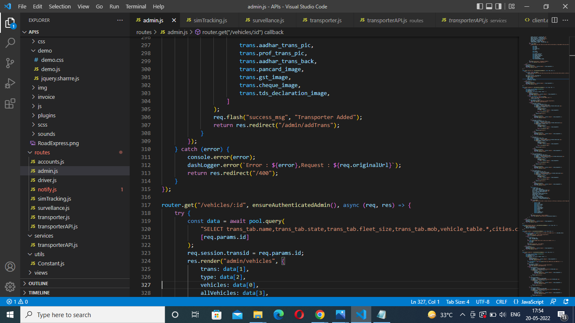

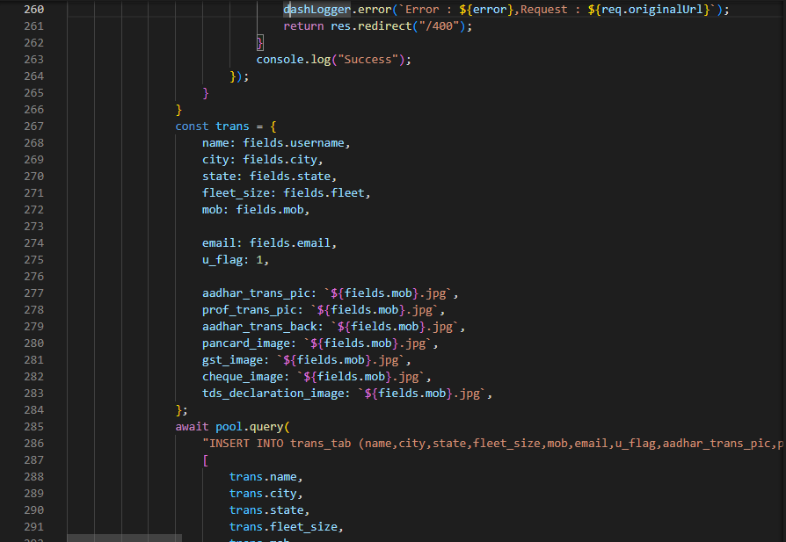

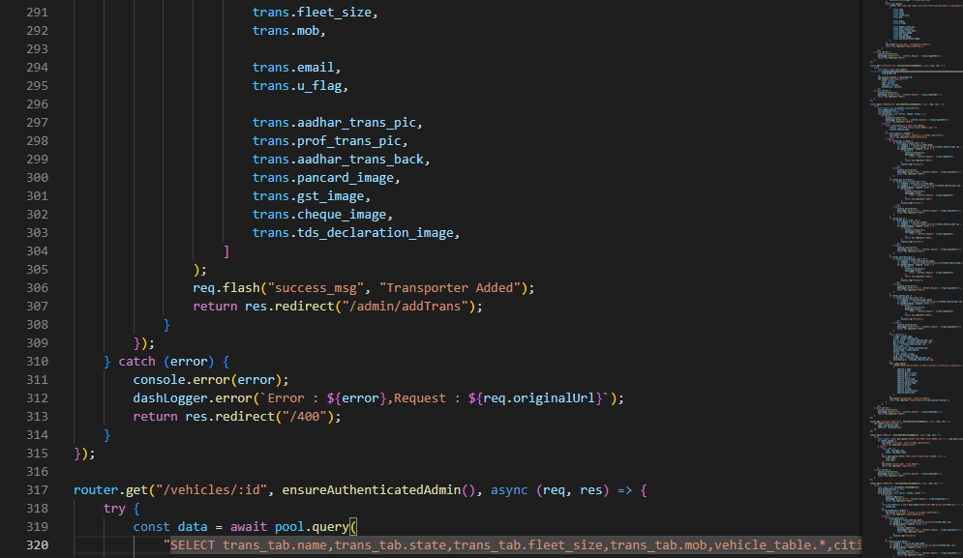

* Find Transporter Data by GET request:

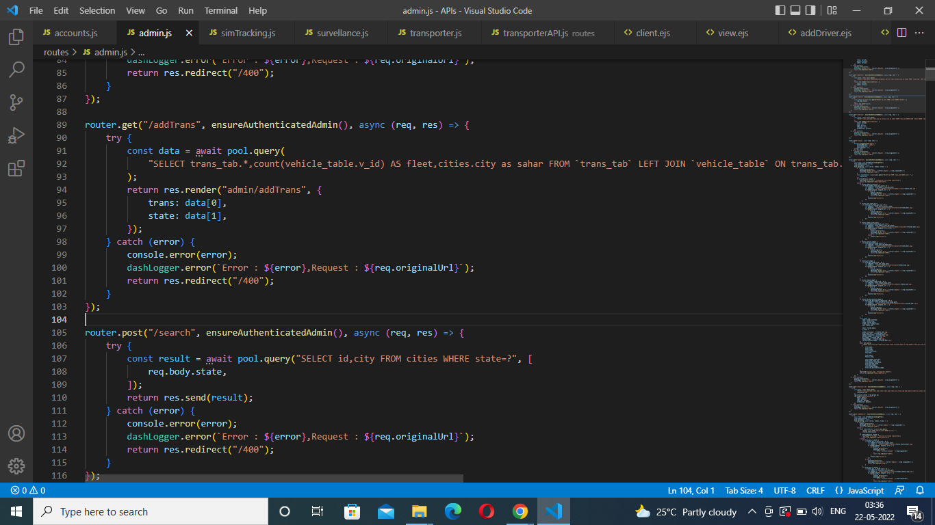

* AddDriver by request: 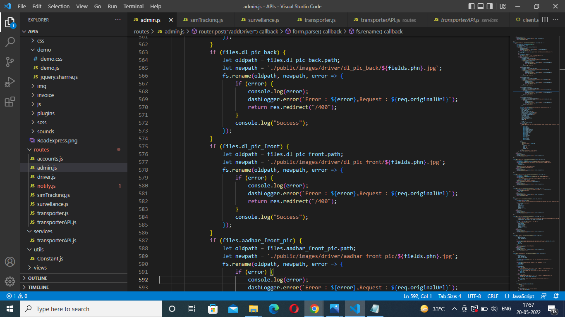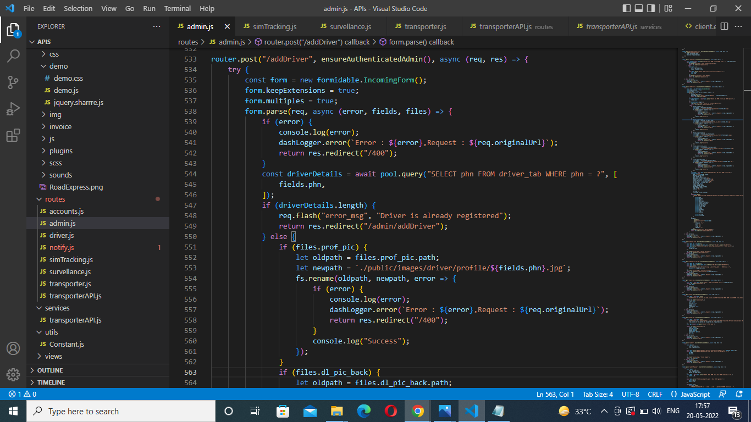
* Add Vehicles by POST request: 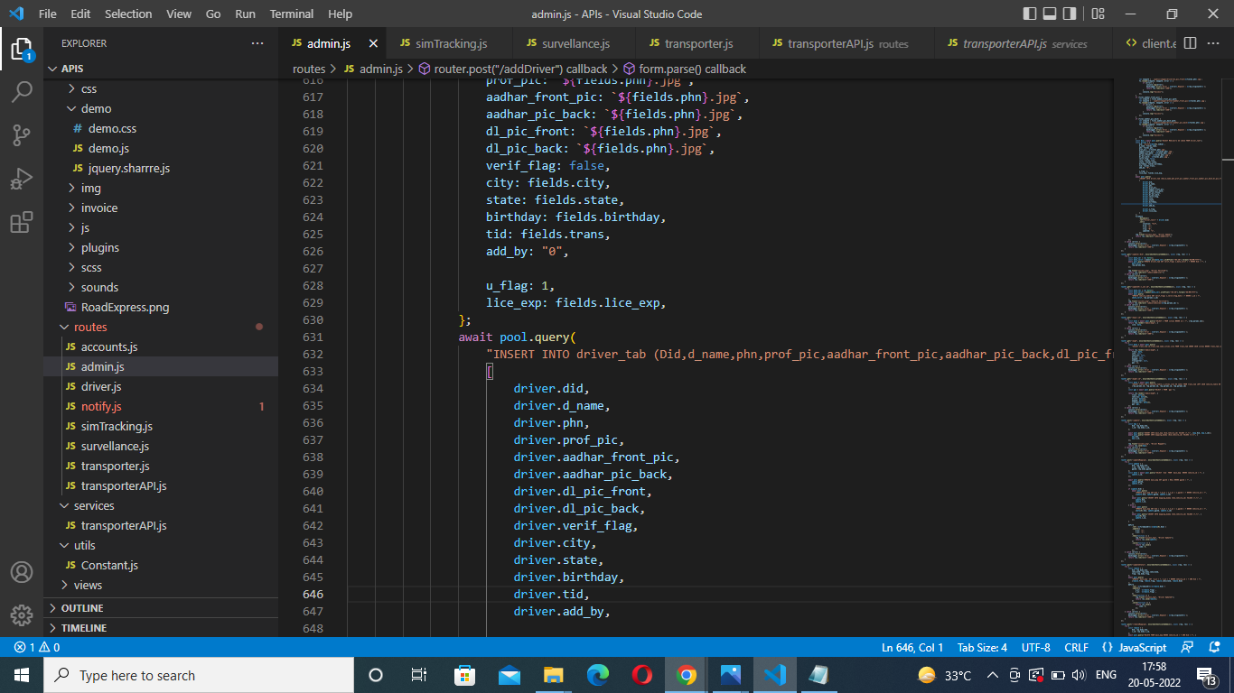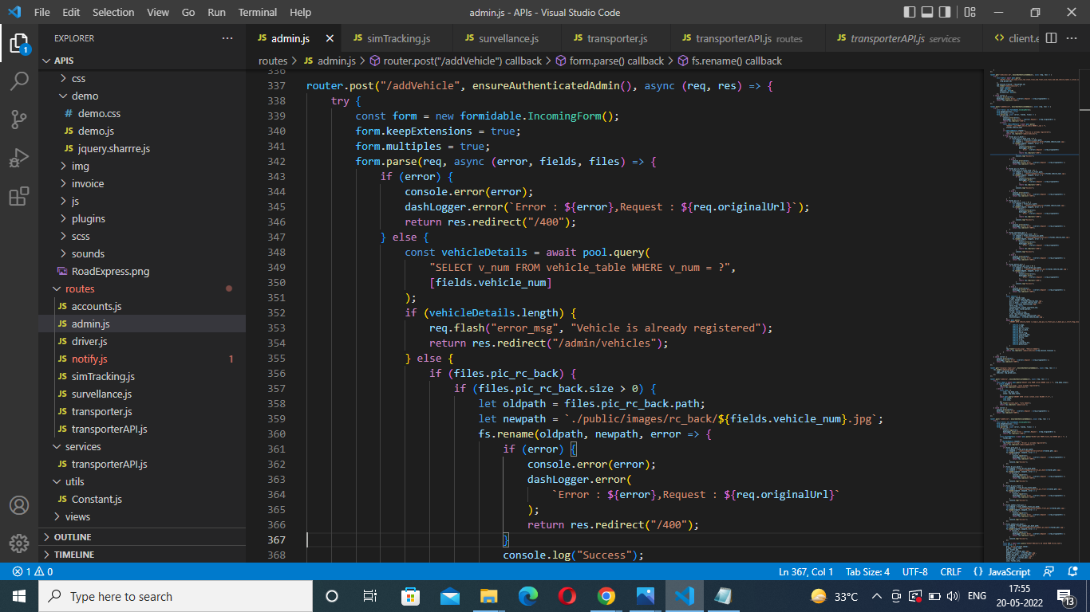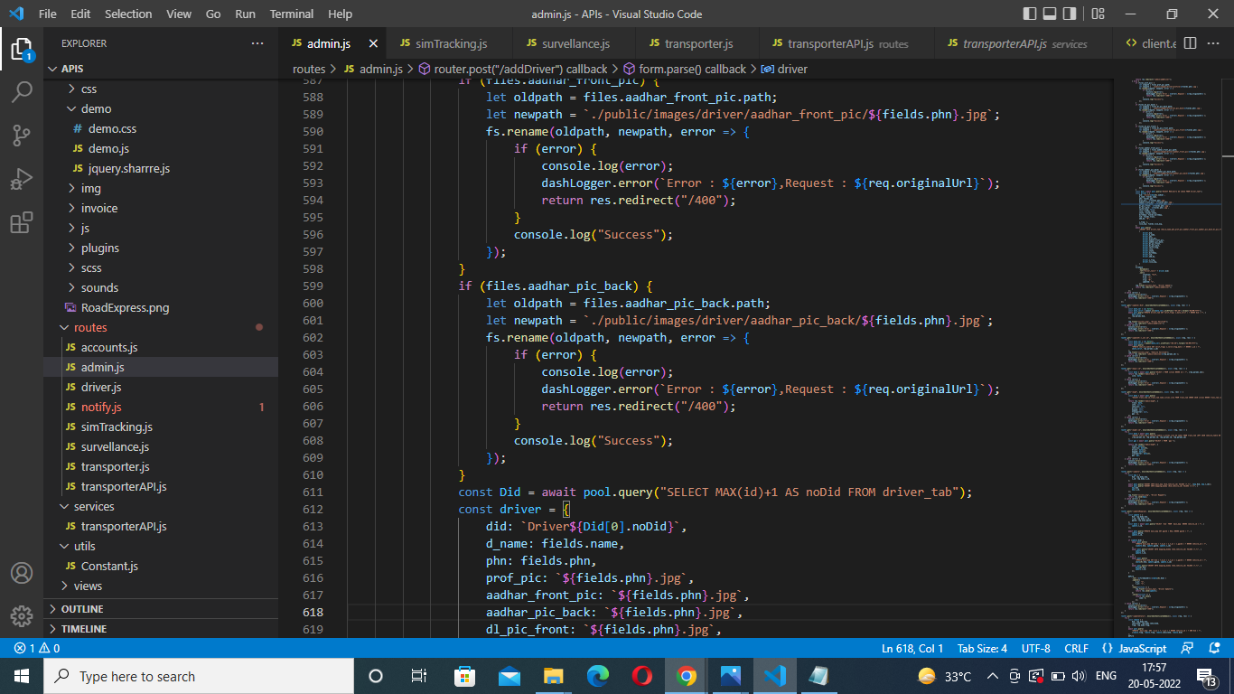

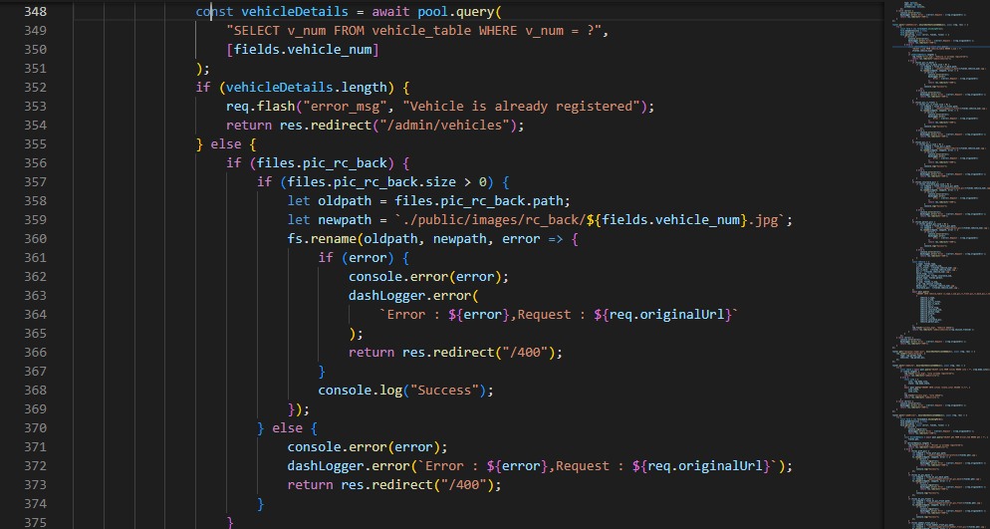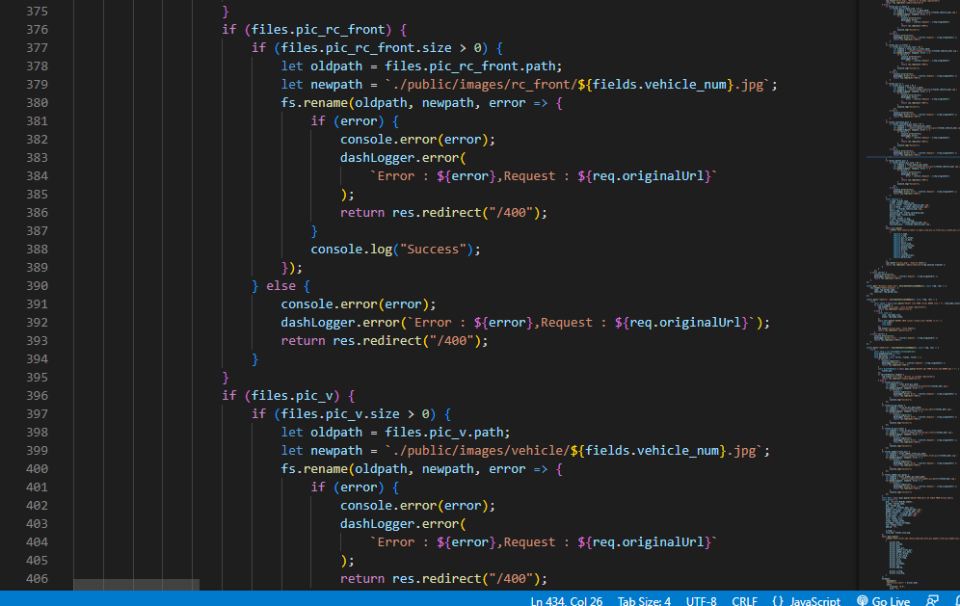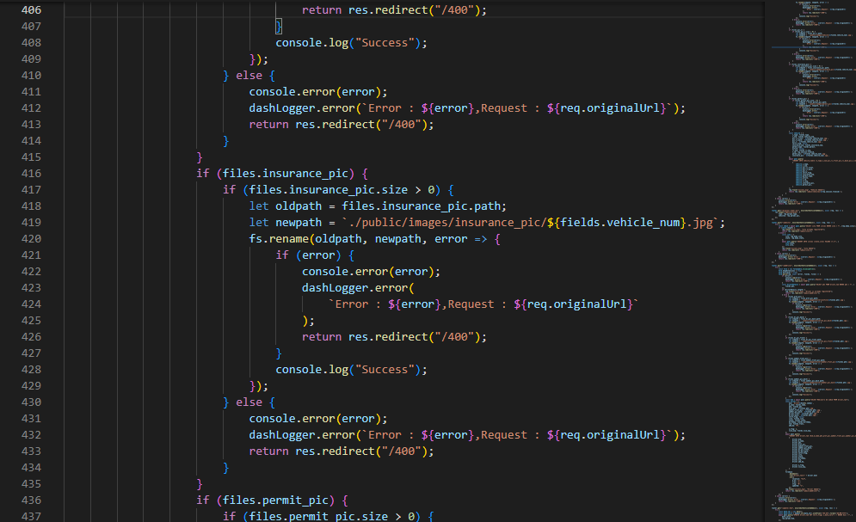

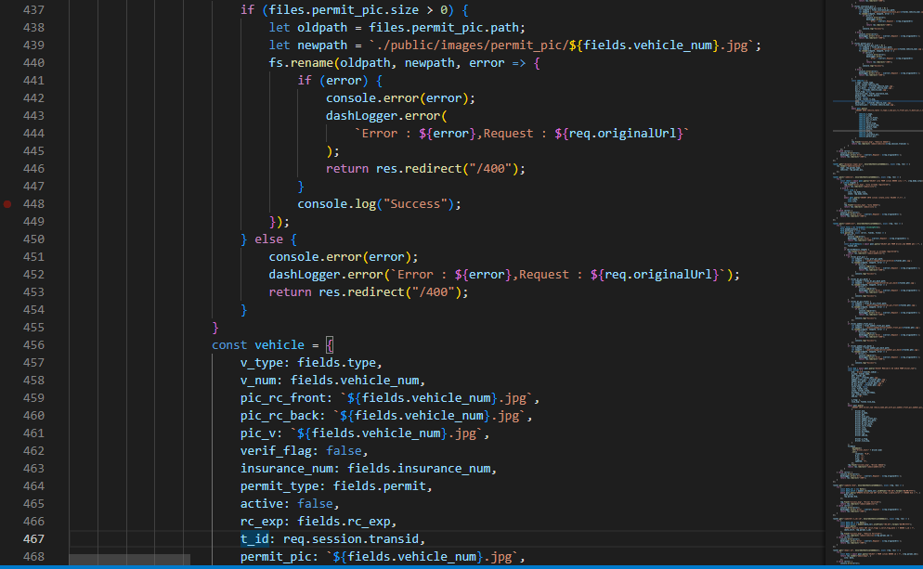

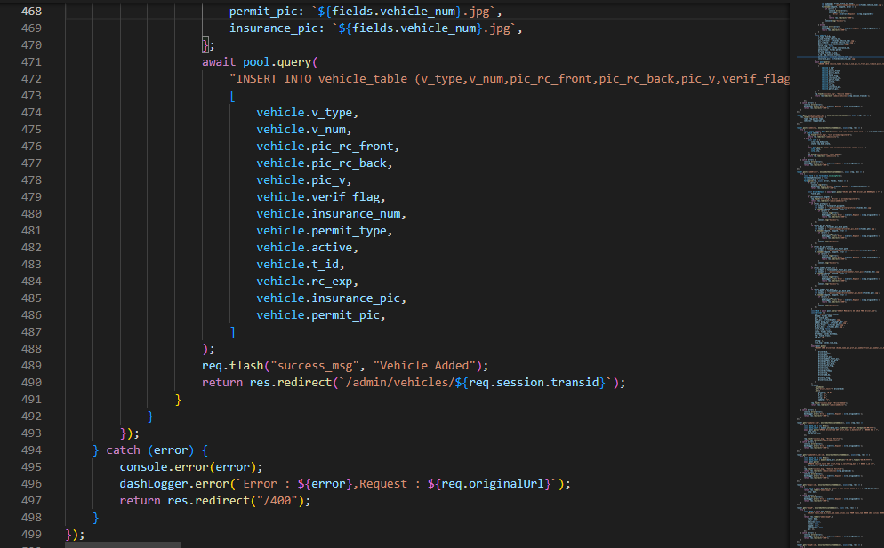

* Find Driver Data by GET Method:

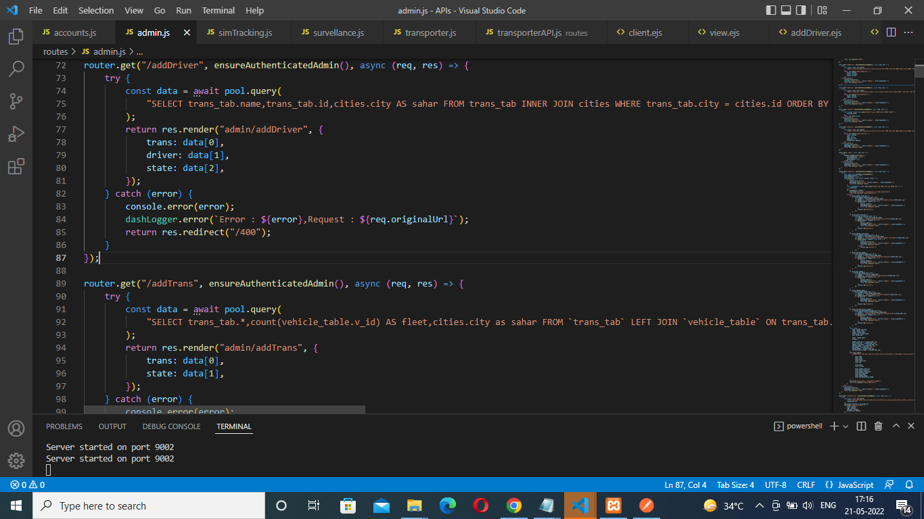

* UPDATE Driver Data by PATCH request:

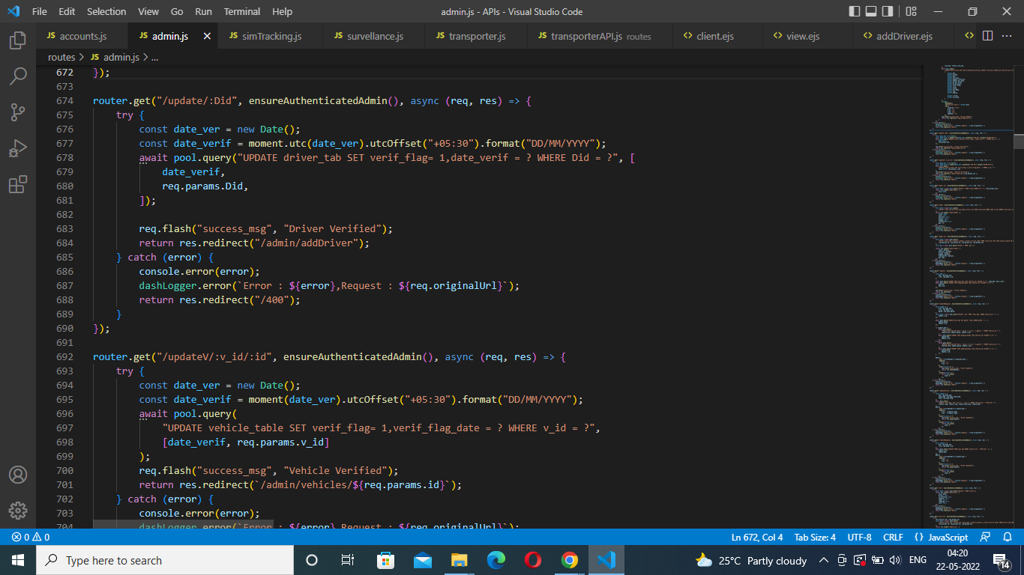

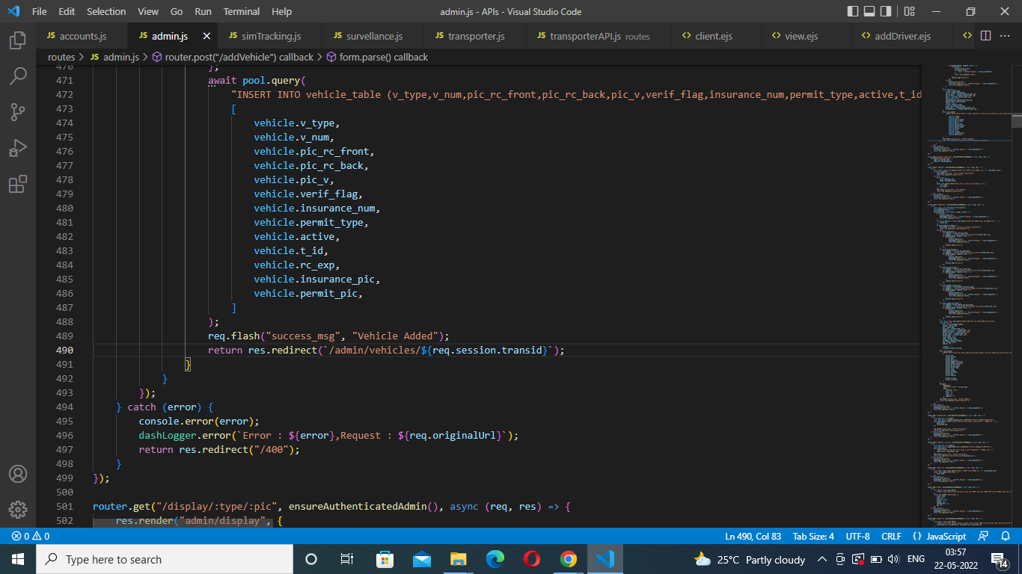

* UPDATE Vehicle Data by Patch method:-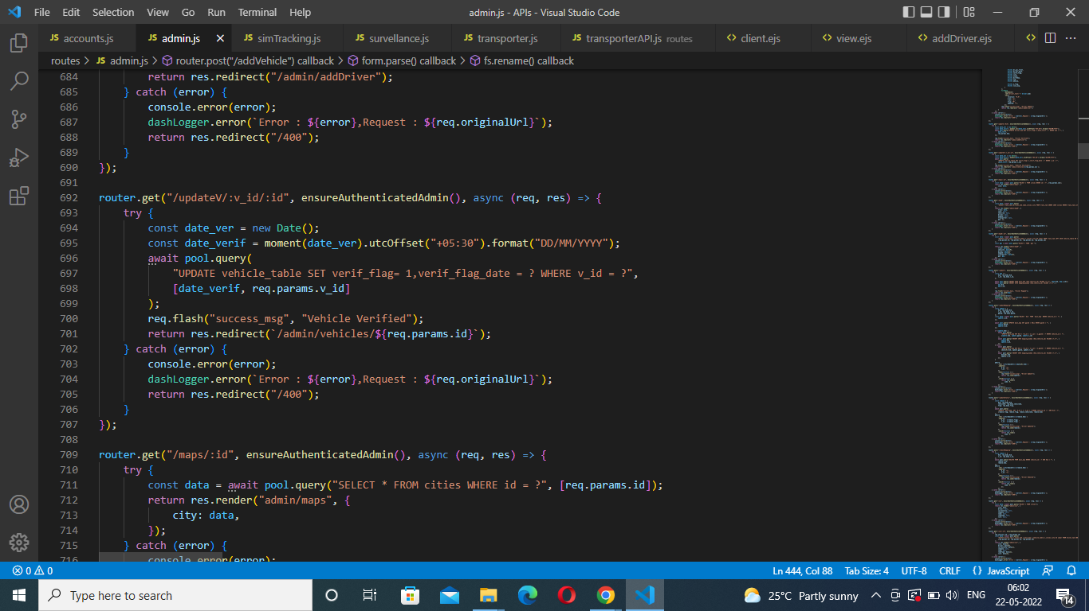
* Find Vehicle Data by id GET Method:

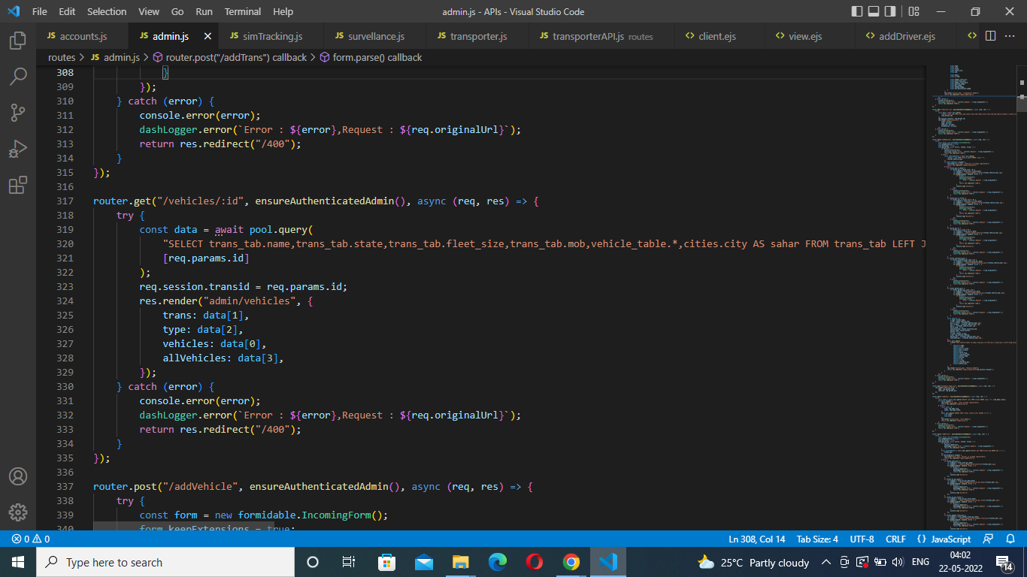

* Find Vehicles Data by GET request:

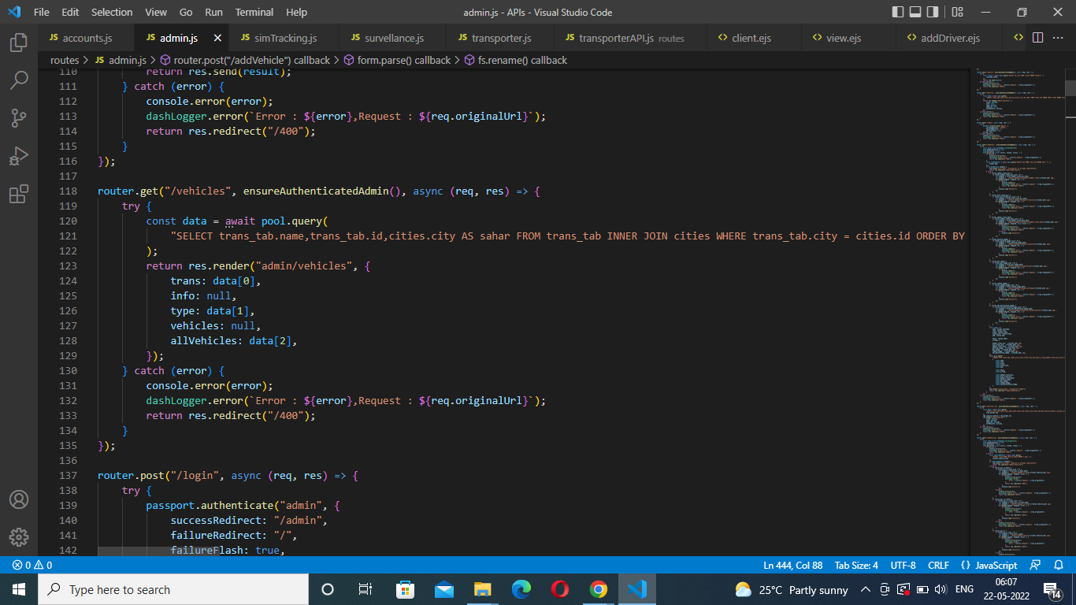

* Add City by POST request:

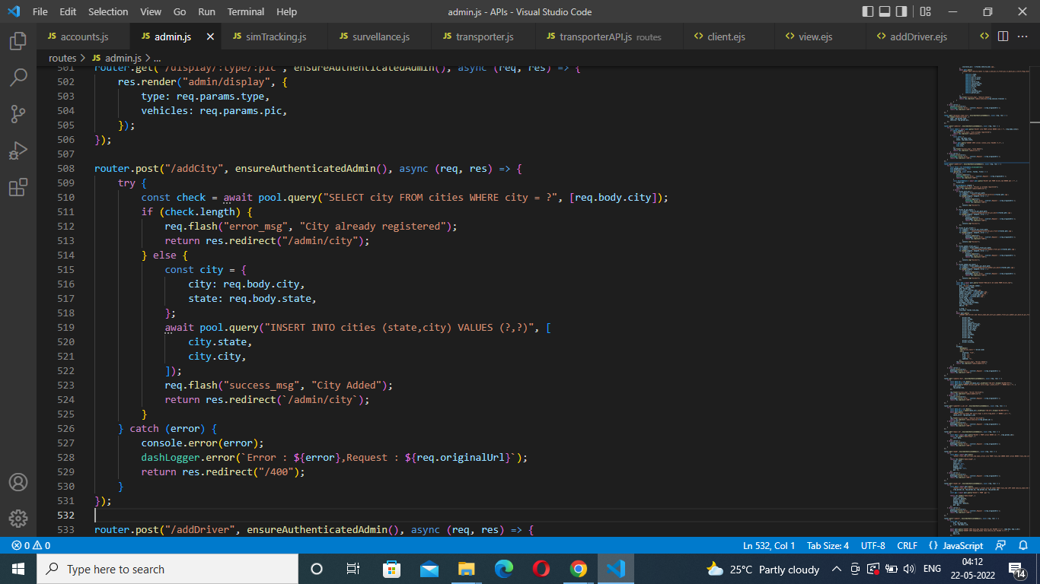

* Find City Data by GET request: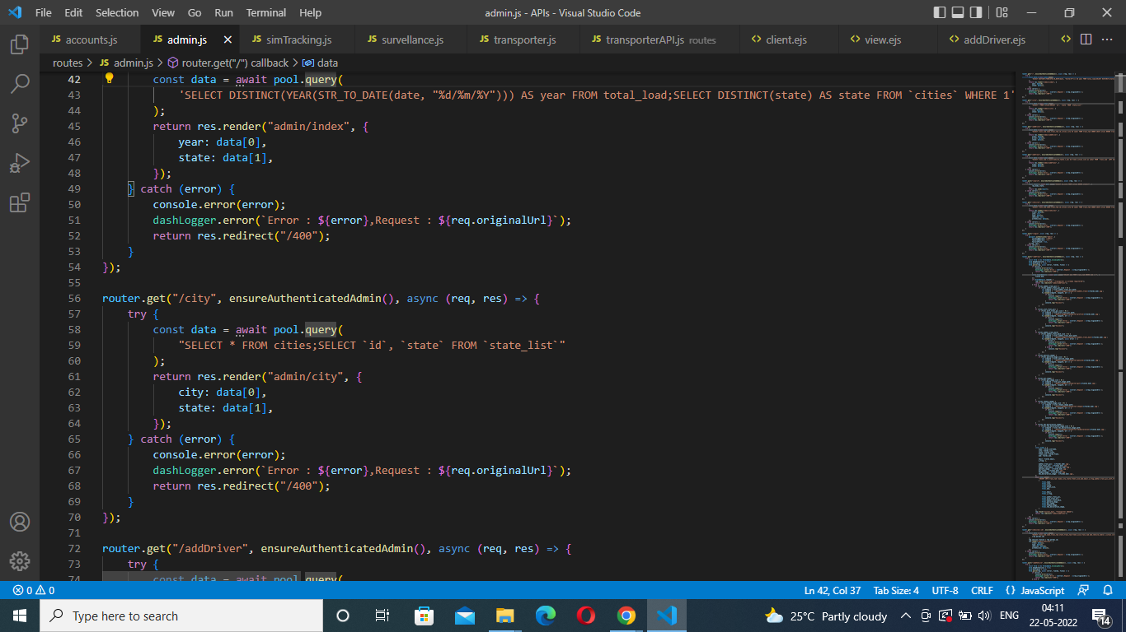
* Add Trip by POST request: 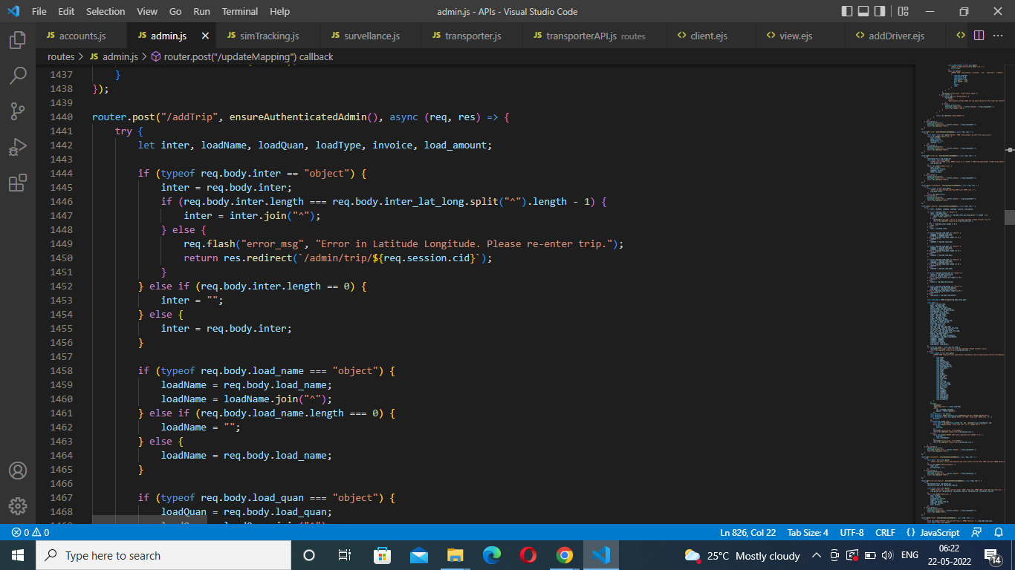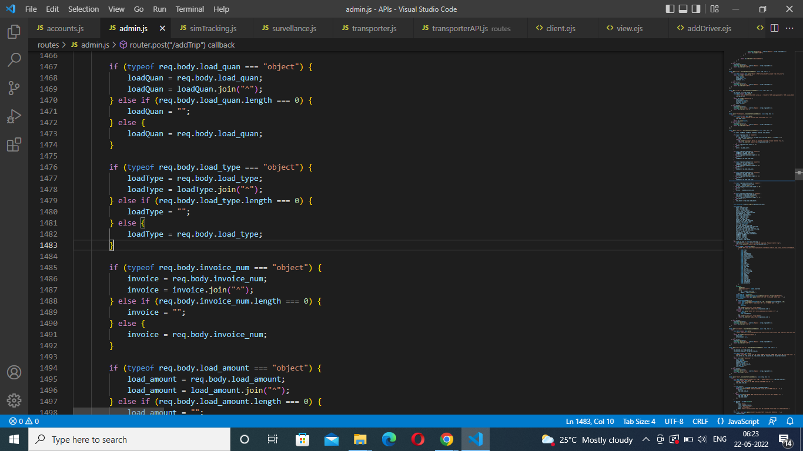
* Find Trip Data by Id GET request:

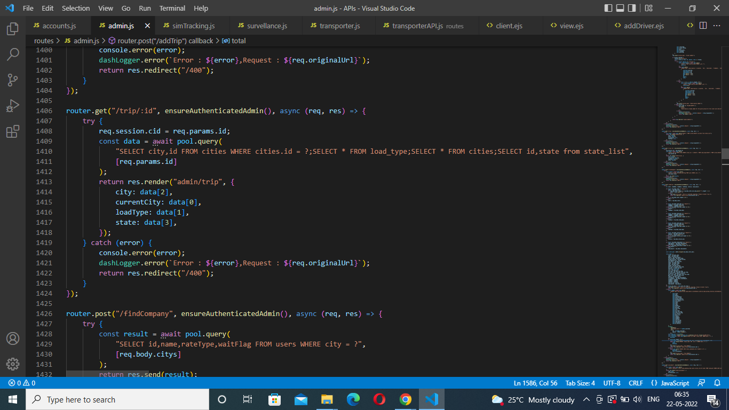

* Find Map Data by GET request:

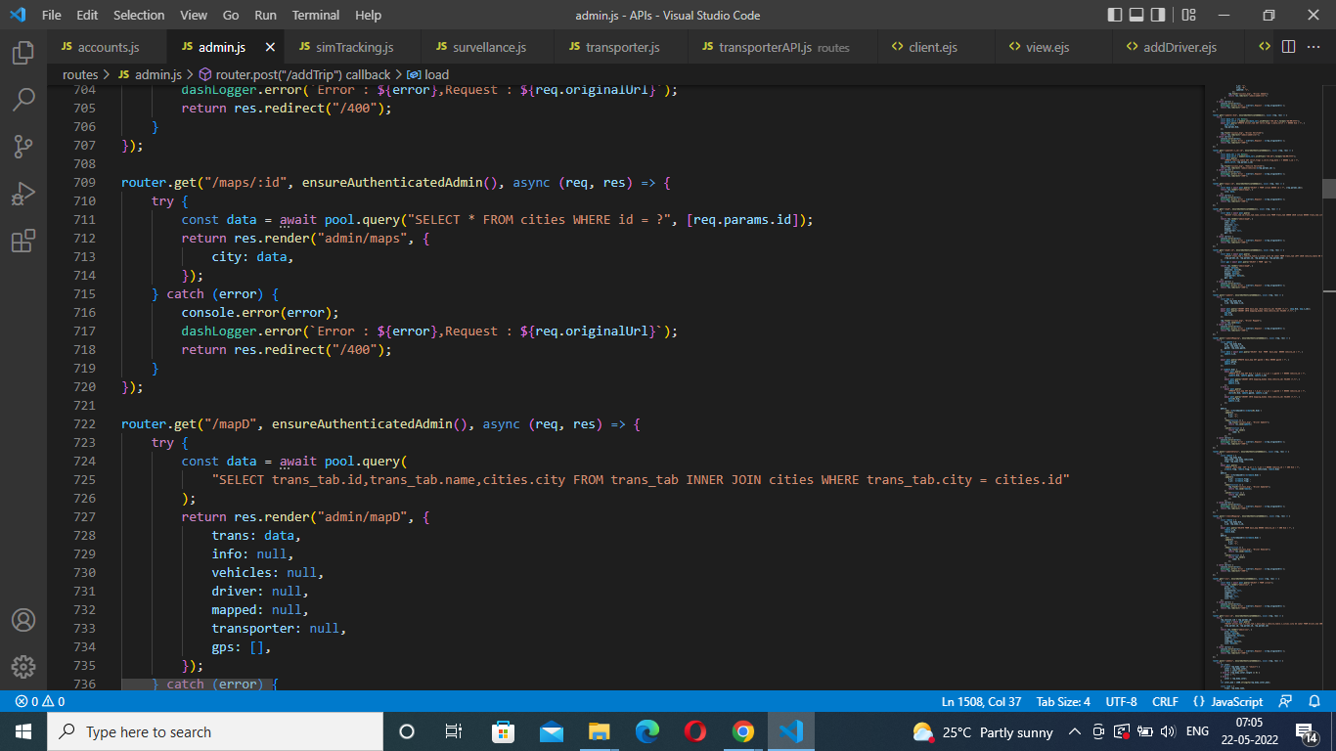

* Map by POST request:

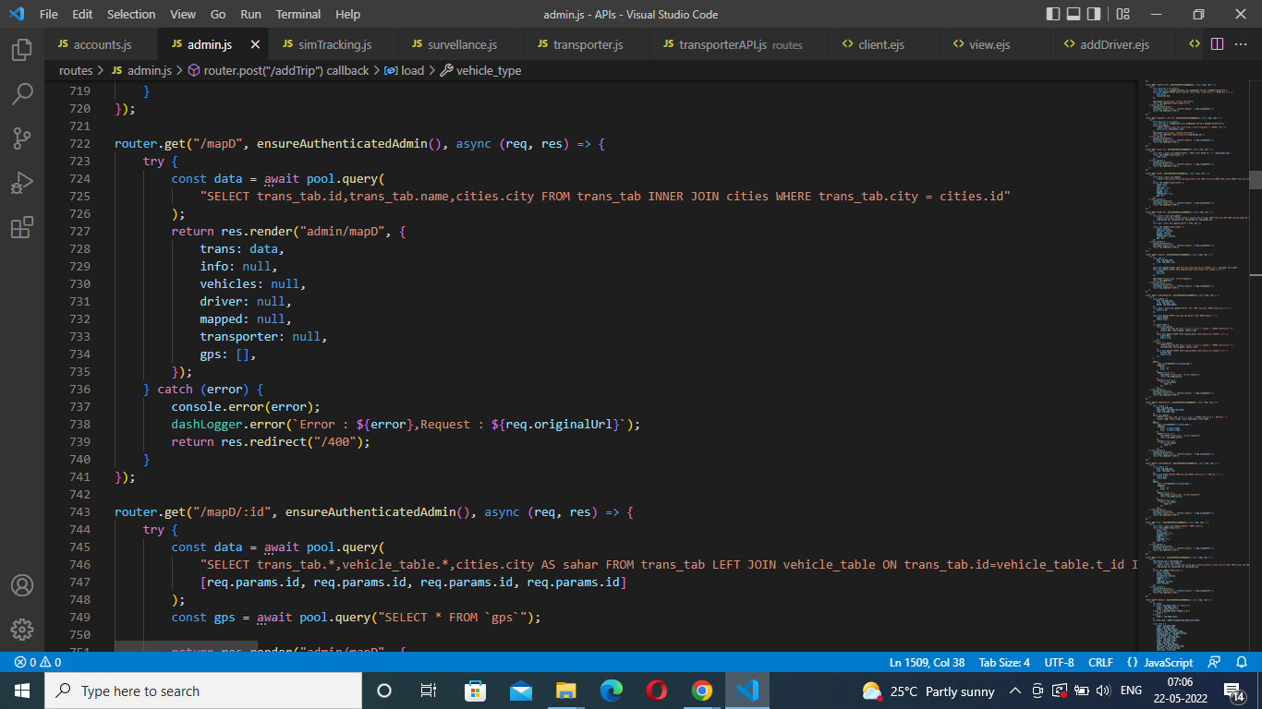

* Find Map Data by ID GET request:

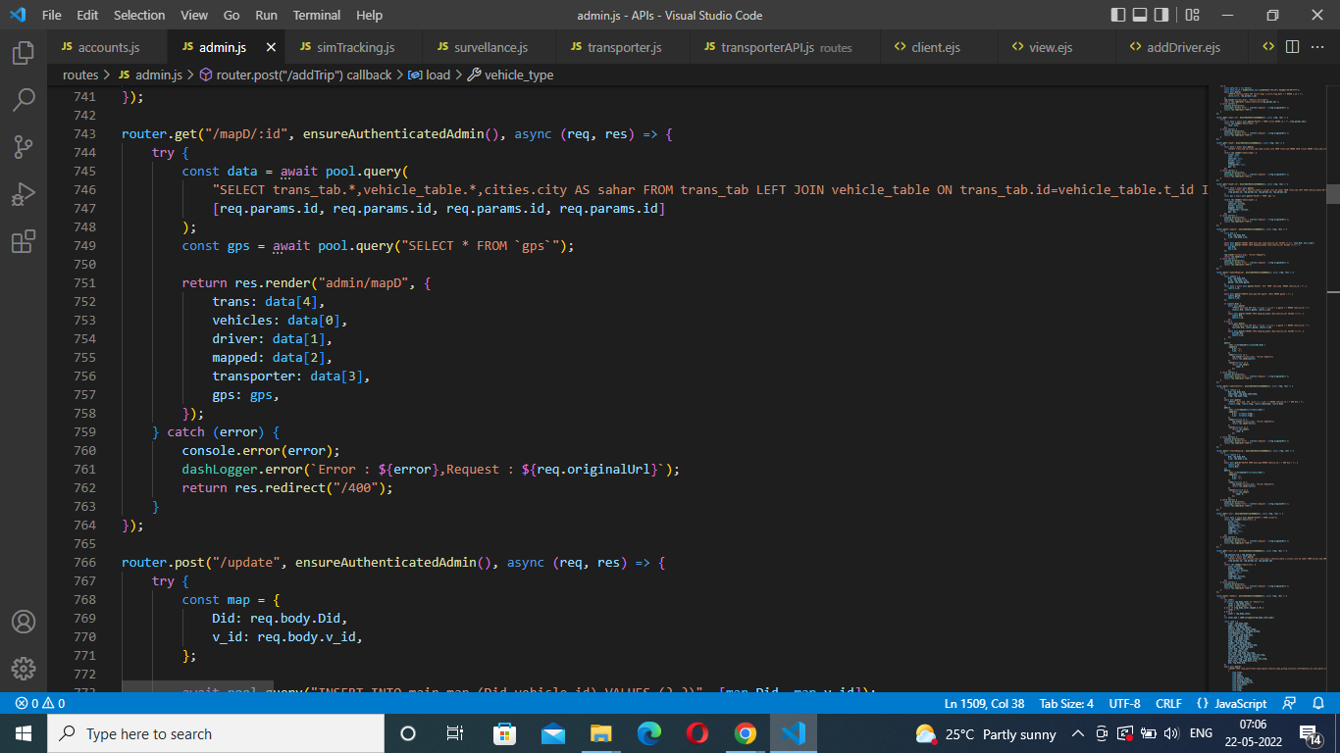

* Add Payment by POST request:

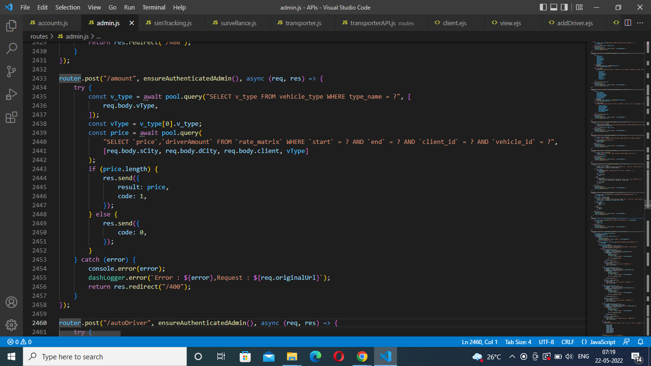

* Add GPS by POST request:

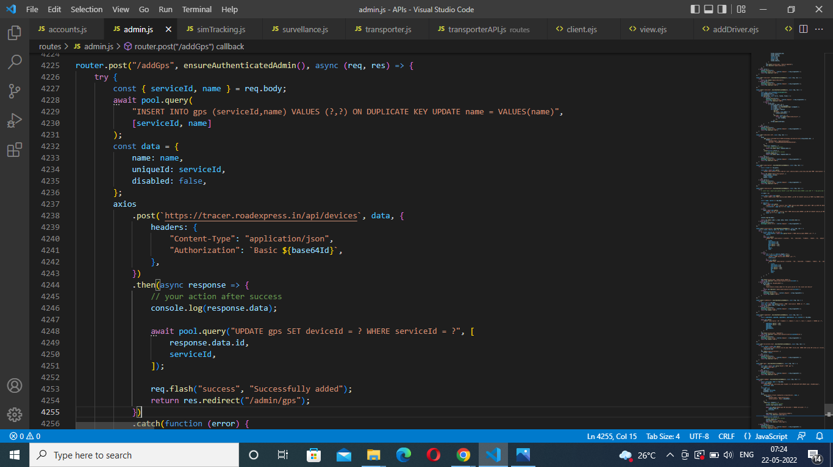

* ADD number(sim_Tracking) by Post request: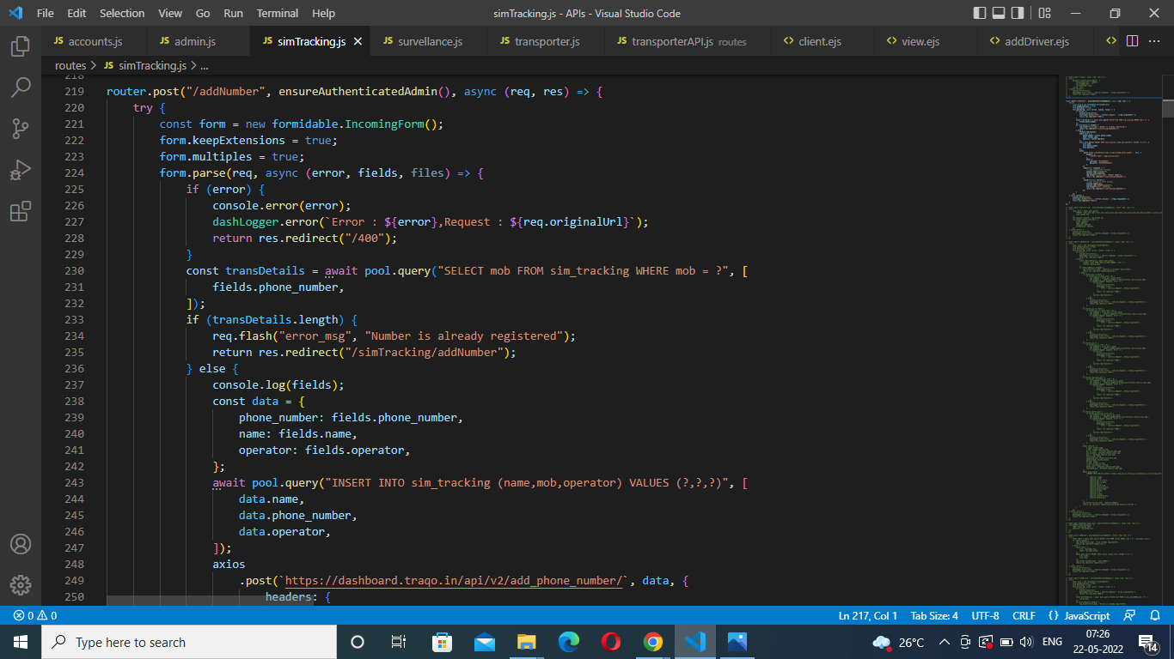

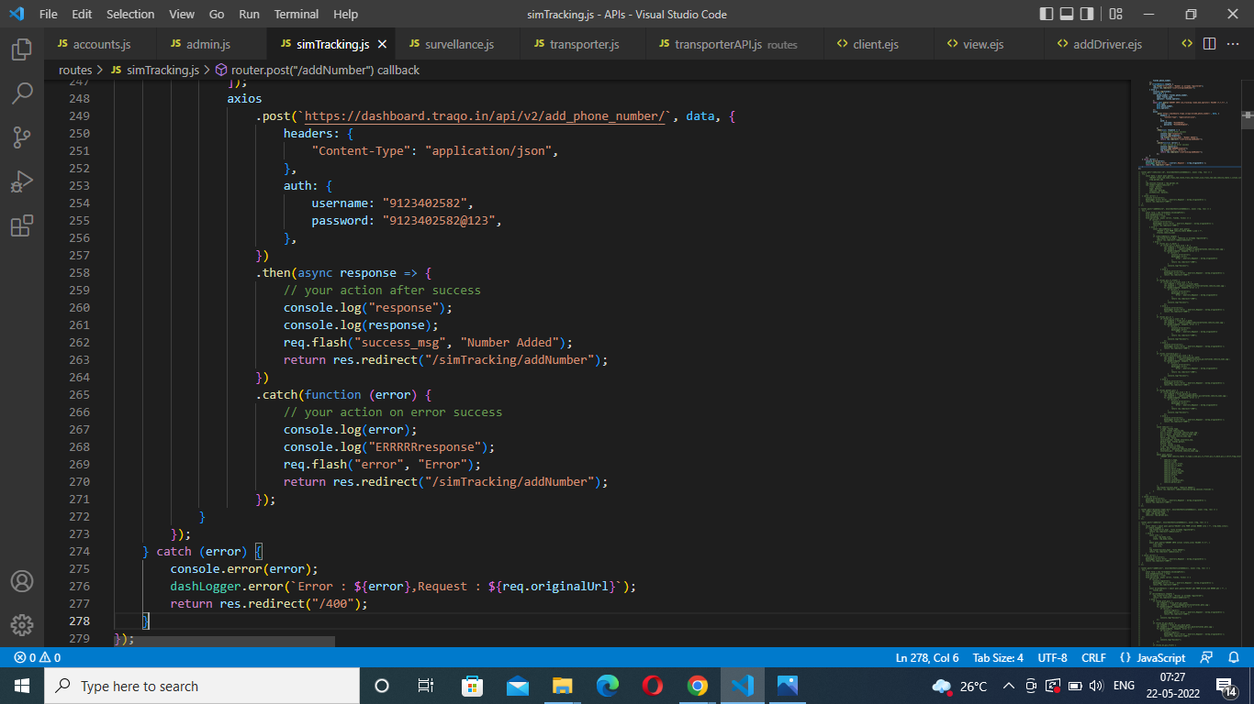

**4.5. BENEFITS :**

* Helpful in Production of Perishable Goods
* By Using this application ,the process of booking transportation ,delivery of the products to its destination ,etc work becomes so easy and sophisticated.
* This application acts as a connecting link between transporters , drivers , customers(clients) ,field workers and other authorized persons.
* By Using this application ,customers(clients) easily get the appropriate solution to their queries immediately.
* By Using this application, customers, transporters, field workers and other people can easily monitor the current status of the vehicle allotment ,product loading or consignment loading and unloading location of a particular vehicle etc.
* By Using this application, customers(clients) also get the details about rate or cost of particular transport booking , consignment loading & unloading ,charges ,etc.This will provide an online transaction facility also that saves time.
* It is user friendly.
* various reports and forms can be generated online easily.

**5. PERFORMANCE REQUIREMENT**

Some Performance requirements identified is listed below:

* This app shall support use of multiple users (AI workers , Farmers ) at a time.
* All the transactions (money transfer process) will be processed within a second.
* Performance speed is high and scalable in real-time development.

* **SOFTWARE PRODUCT FEATURE**

**Validity checks**: JAVA Script , Node validation package checks for various fields in the particular forms in our application.

**Sequencing Information**: All the information regarding AI workers ,Farmers and admin should be handled sequentially, that is data should be stored in a particular sequence to avoid any inconvenience.

**Error Handling**: If any of the validations or sequencing flows does not hold true then appropriate error messages will be prompted to the user for doing the needful.

* **SOFTWARE PRODUCT ATTRIBUTES**

**Security :** Only authorised users will be able to access the application by entering the correct login id and password according to the login credential process.

**Maintainability:** This application can be maintained in present and future. It will be easy to incorporate new requirements in the individual module.

**Portability:** As the application is online so will be easily portable on the various mobile operating systems.

**Reliability:** The application should be highly reliable and it should generate all the updated information in correct order.

**6 . SYSTEM DESIGN AND OVERVIEW**

**6.1 FLOW CHART**

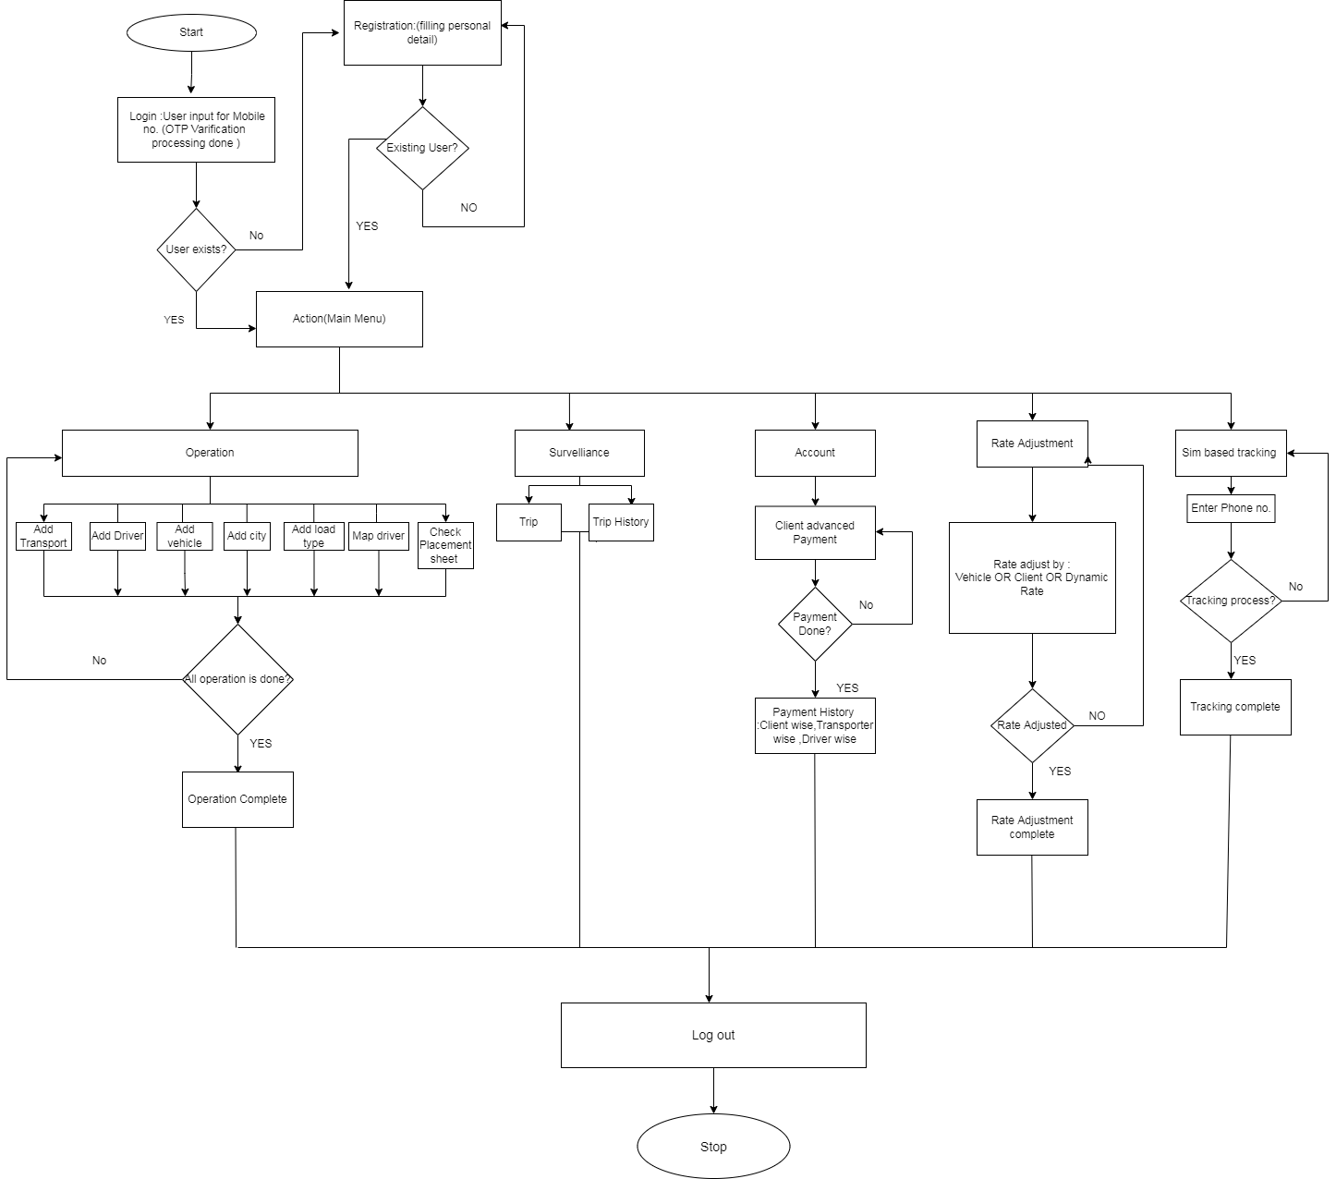

**6.2 DATABASE DESIGN**

The project uses Firebase for Android in which it is a NoSQL database. Unlike conventional SQL databases, it does not have any tables or records. Data is stored as JSON objects and nodes with associated keys exist in JSON structure so that it can be used to identify data uniquely. For the usage of this project, there are following directories in the database as shown in Figure 6.2.1:

fig:6.2.1:Database Structure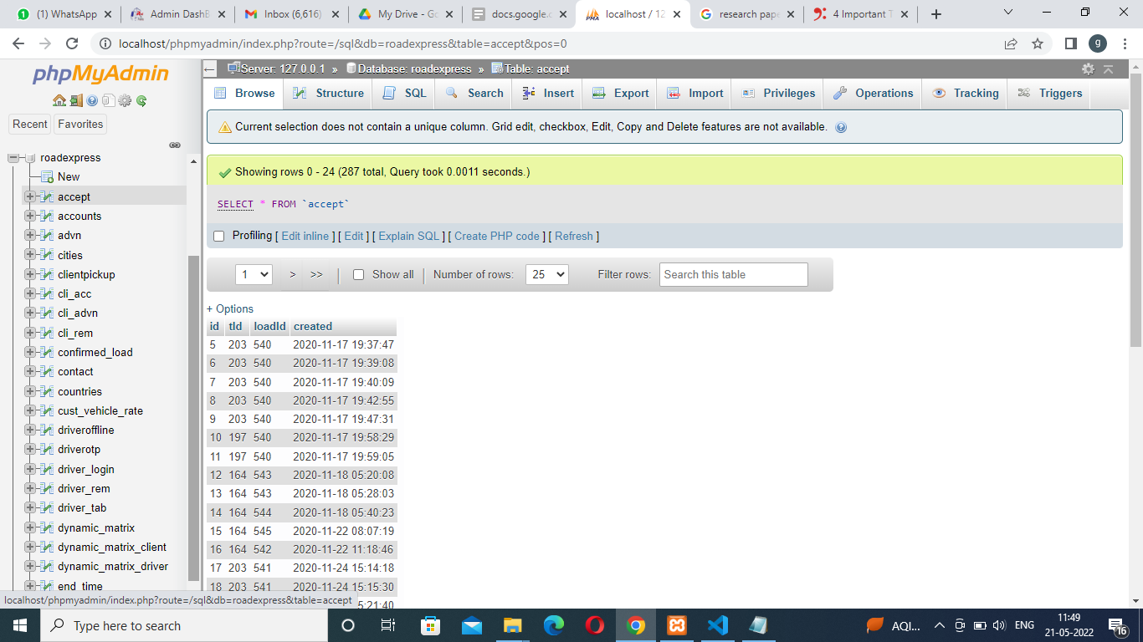

**6.3 DATA DICTIONARY**

1.Table Name: **Trans_login**

| **ATTRIBUTE** | **DATA-TYPE** | **SIZE** | **NULL** | **DEFAULT** | **CONSTRAINTS** | **EXTRA** |
| --- | --- | --- | --- | --- | --- | --- |
| Id | int | 11 | No |  |  | Auto_increment |
| Mob_no | varchar | 250 | Yes | NULL |  |  |

2.Table Name: **Trans_tab**

| **ATTRIBUTE** | **DATA-TYPE** | **SIZE** | **NULL** | **DEFAULT** | **CONSTRAINTS** | **EXTRA** |
| --- | --- | --- | --- | --- | --- | --- |
| id | int | 11 | No |  |  | Auto_increment |
| name | varchar | 50 | Yes | NULL |  |  |
| city | varchar | 50 | Yes | NULL |  |  |
| mob | bigint | 20 | Yes | NULL |  |  |
| state | varchar | 50 | Yes | NULL |  |  |
| country | int | 11 | Yes | NULL |  |  |
| fleet_size | varchar | 50 | Yes | NULL |  |  |
| doj | datetime |  | No | CURRENT_TIMESTAMP |  |  |
| add_by | int | 11 | No | 0 |  |  |
| bankAcc | varchar | 50 | Yes | NULL |  |  |
| email | varchar | 200 | Yes | NULL |  |  |
| acc_name | varchar | 100 | Yes | NULL |  |  |
| ifsc | varchar | 50 | Yes | NULL |  |  |
| aadhar_trans_pic | varchar | 100 | Yes | NULL |  |  |
| aadhar_trans_back | varchar | 100 | Yes | NULL |  |  |
| pancard_image | varchar | 255 | Yes | NULL |  |  |
| cheque_image | varchar | 255 | Yes | NULL |  |  |
| gst_image | varchar | 255 | Yes | NULL |  |  |
| tds_declaration_image | varchar | 255 | Yes | NULL |  |  |
| u_flag | int | 11 | Yes | 0 |  |  |
| referralCode | varchar | 50 | Yes | NULL |  |  |
| referred | varchar | 50 | Yes | NULL |  |  |
| fcm_token | text |  | Yes | NULL |  |  |
| created | timestamp |  | No | CURRENT_TIMESTAMP |  |  |

3.Table Name: **Vehicle_table**

| **ATTRIBUTE** | **DATA-TYPE** | **SIZE** | **NULL** | **DEFAULT** | **CONSTRAINT** | **EXTRA** |
| --- | --- | --- | --- | --- | --- | --- |
| v_id | int | 11 | No |  |  | Auto_increment |
| v_type | varchar | 50 | Yes | NULL |  |  |
| v_num | varchar | 50 | Yes | NULL |  |  |
| pic_rc_front | varchar | 50 | Yes | NULL |  |  |
| pic_rc_back | varchar | 50 | Yes | NULL |  |  |
| pic_v | varchar | 50 | Yes | NULL |  |  |
| verif_flag | tinyint | 1 | No | 0 |  |  |
| insurance_num | varchar | 50 | No | NULL |  |  |
| add_date | datetime |  | No | CURRENT_TIMESTAMP |  |  |
| verif__flag_date | varchar | 100 | Yes | NULL |  |  |
| permit_type | varchar | 50 | Yes | NULL |  |  |
| active | tinyint | 1 | Yes | NULL |  |  |
| t_id | int | 100 | Yes | NULL |  |  |
| u_flag | int | 10 | No | 0 |  |  |
| rc_num | varchar | 50 | Yes | NULL |  |  |
| rc_exp | varchar | 45 | Yes | NULL |  |  |
| insurance_pic | varchar | 100 | Yes | NULL |  |  |
| permit_pic | varchar | 100 | Yes | NULL |  |  |
| fitness_pic | varchar | 100 | Yes | NULL |  |  |
| insurance_expiry_pic | varchar | 100 | Yes | NULL |  |  |

4.Table Name: **Vehicle_type**

| **ATTRIBUTE** | **DATA-TYPE** | **SIZE** | **NULL** | **DEFAULT** | **CONSTRAINT** | **EXTRA** |
| --- | --- | --- | --- | --- | --- | --- |
| v_type | int | 11 | No |  |  |  |
| type_name | varchar | 45 | No |  |  |  |
| v_type_img | text |  | Yes | NULL |  |  |
| dimension | varchar | 45 | No |  |  |  |
| capacity | int | 11 | No |  |  |  |

5.Table Name: **rate_matrix_vehicle**

| **ATTRIBUTE** | **DATA-TYPE** | **SIZE** | **NULL** | **DEFAULT** | **CONSTRAINT** | **EXTRA** |
| --- | --- | --- | --- | --- | --- | --- |
| v_type | int | 11 | No |  |  |  |
| type_name | varchar | 45 | No |  |  |  |
| v_type_img | text |  | Yes | NULL |  |  |
| dimension | varchar | 45 | No |  |  |  |
| capacity | int | 11 | No |  |  |  |

6.Table Name: **driver_login**

| **ATTRIBUTE** | **DATA-TYPE** | **SIZE** | **NULL** | **DEFAULT** | **CONSTRAINT** | **EXTRA** |
| --- | --- | --- | --- | --- | --- | --- |
| id | int | 11 | No |  |  | Auto_increment |
| Did | varchar | 11 | Yes | NULL |  |  |
| phone_no | varchar | 250 | Yes | NULL |  |  |

7.Table Name: **driver_otp**

| **ATTRIBUTE** | **DATA-TYPE** | **SIZE** | **NULL** | **DEFAULT** | **CONSTRAINT** | **EXTRA** |
| --- | --- | --- | --- | --- | --- | --- |
| mob | varchar | 12 | No |  |  |  |
| otp | varchar | 14 | Yes | NULL |  |  |

8.Table Name: **driver_tab**

| **ATTRIBUTE** | **DATA-TYPE** | **SIZE** | **NULL** | **DEFAULT** | **CONSTRAINT** | **EXTRA** |
| --- | --- | --- | --- | --- | --- | --- |
| id | int | 10 | No |  |  | auto_increment |
| Did | varchar | 11 | No | NULL |  |  |
| d_name | varchar | 50 | Yes | NULL |  |  |
| phone_no | bigint | 20 | Yes | NULL |  |  |
| city | varchar | 50 | Yes | NULL |  |  |
| state | varchar | 50 | Yes | NULL |  |  |
| country | int | 11 | Yes | NULL |  |  |
| aadhar_front_pic | varchar | 50 | Yes | NULL |  |  |
| aadhar_pic_back | varchar | 50 | Yes | NULL |  |  |
| prof_pic | varchar | 50 | Yes | NULL |  |  |
| dl_pic_front | varchar | 50 | Yes | NULL |  |  |
| dl_pic_back | varchar | 50 | Yes | NULL |  |  |
| birthday | varchar | 50 | Yes | NULL |  |  |
| dlNo | varchar | 100 | Yes | NULL |  |  |
| verif_flag | int | 11 | Yes | NULL |  |  |
| date_verif | varchar | 100 | Yes | NULL |  |  |
| add_day | datetime |  | No | CURRENT_TIMESTAMP |  |  |
| add_by | int | 11 | Yes | NULL |  |  |
| tid | int | 11 | Yes | NULL |  |  |
| bankAccd | varchar | 50 | Yes | NULL |  |  |
| u_flag | int | 10 | No | 0 |  |  |
| lice_exp | varchar | 45 | Yes | NULL |  |  |
| acc_name | varchar | 100 | Yes | NULL |  |  |
| ifsc | varchar | 50 | Yes | NULL |  |  |
| fcm_token | text |  | Yes | NULL |  |  |
| active | int | 2 | No | 0 |  |  |
| permission | text |  | Yes | NULL |  |  |

9.Table Name: **driver offline**

| **ATTRIBUTE** | **DATA-TYPE** | **SIZE** | **NULL** | **DEFAULT** | **CONSTRAINT** | **EXTRA** |
| --- | --- | --- | --- | --- | --- | --- |
| id | int | 11 | No |  |  | auto_increment |
| driver | text |  | Yes | NULL |  |  |
| date | varchar | 20 | Yes | NULL |  |  |
| time | varchar | 10 | Yes | NULL |  |  |
| marked | enum(‘Yes’,’No’) |  | No | NULL |  |  |
| created | datetime |  | No | CURRENT_TIMESTAMP |  |  |

10.Table Name: **driver online**

| **ATTRIBUTE** | **DATA-TYPE** | **SIZE** | **NULL** | **DEFAULT** | **CONSTRAINT** | **EXTRA** |
| --- | --- | --- | --- | --- | --- | --- |
| id | int | 11 | No |  |  | auto_increment |
| driver | text |  | Yes | NULL |  |  |
| date | varchar | 20 | Yes | NULL |  |  |
| time | varchar | 10 | Yes | NULL |  |  |
| marked | enum(‘Yes’,’No’) |  | No | NULL |  |  |
| created | datetime |  | No | CURRENT_TIMESTAMP |  |  |

11.Table Name: **driver_rem**

| **ATTRIBUTE** | **DATA-TYPE** | **SIZE** | **NULL** | **DEFAULT** | **CONSTRAINT** | **EXTRA** |
| --- | --- | --- | --- | --- | --- | --- |
| id | int | 11 | No |  |  | auto_increment |
| Did | varchar | 100 | Yes | NULL |  |  |
| total | varchar | 100 | Yes | NULL |  |  |

12.Table Name: **loadInfo**

| **ATTRIBUTE** | **DATA-TYPE** | **SIZE** | **NULL** | **DEFAULT** | **CONSTRAINT** | **EXTRA** |
| --- | --- | --- | --- | --- | --- | --- |
| id | int | 11 | No |  |  | auto_increment |
| loadName | varchar | 200 | Yes | NULL |  |  |
| loadQuan | text |  | Yes | NULL |  |  |
| loadType | text |  | Yes | NULL |  |  |
| loadAmount | text |  | Yes | NULL |  |  |
| invoiceNum | text |  | Yes | NULL |  |  |
| loadId | int | 11 | No | NULL |  |  |
| type | varchar | 20 | Yes |  |  |  |
| difference | int | 11 | Yes | 0 |  |  |

13.Table Name: **loadInfoSave**

| **ATTRIBUTE** | **DATA-TYPE** | **SIZE** | **NULL** | **DEFAULT** | **CONSTRAINT** | **EXTRA** |
| --- | --- | --- | --- | --- | --- | --- |
| id | int | 11 | No |  |  | auto_increment |
| loadName | text |  | Yes | NULL |  |  |
| loadQuan | text |  | Yes | NULL |  |  |
| loadType | text |  | Yes | NULL |  |  |
| loadAmount | text |  | Yes | NULL |  |  |
| invoiceNum | text |  | Yes | NULL- |  |  |
| savedloadId | int | 11 | No |  |  |  |
| type | varchar |  | Yes | NULL |  |  |
| difference | int | 11 | Yes | 0 |  |  |

14.Table Name: **load_post**

| **ATTRIBUTE** | **DATA-TYPE** | **SIZE** | **NULL** | **DEFAULT** | **CONSTRAINT** | **EXTRA** |
| --- | --- | --- | --- | --- | --- | --- |
| load_id | int | 11 | No |  |  | auto_increment |
| flag | int | 11 | No | 0 |  |  |
| fromc | varchar | 100 | Yes | NULL |  |  |
| t_id | int | 50 | Yes | NULL |  |  |
| time | datetime |  | No | CURRENT_TIMESTAMP |  |  |
| status | int | 11 | No | 0 |  |  |
| payment_status | enum(‘unpal’,’paid’) |  | No | unpaid |  |  |
| supervisor | int | 11 | No | 0 |  |  |
| type | varchar | 50 | Yes | NULL |  |  |
| amount | varchar | 50 | Yes | NULL |  |  |
| clientAmount | varchar | 50 | Yes | NULL |  |  |
| vehicle_type | varchar | 50 | Yes | NULL |  |  |
| pickup_location | text |  | Yes | NULL |  |  |
| lat_long | varchar | 200 | Yes | NULL |  |  |
| inter_lat_long | text | 250 | Yes | NULL |  |  |
| city | varchar | 250 | Yes | NULL |  |  |
| dest_city | varchar | 100 | Yes | NULL |  |  |
| intermediate_loc | text |  | Yes | NULL |  |  |
| last_point | text |  | Yes | NULL |  |  |
| timef | varchar | 50 | Yes | NULL |  |  |
| timet | varchar | 50 | Yes | NULL |  |  |
| weight | int | 25 | Yes | NULL |  |  |
| inter_mob | text |  | Yes | NULL |  |  |
| total_stops | int | 11 | Yes | NULL |  |  |
| start_mob | varchar | 15 | Yes | NULL |  |  |
| end_mob | varchar | 15 | Yes | NULL |  |  |
| no_vehicle | int | 60 | Yes | NULL |  |  |
| remaining | int | 11 | Yes | NULL |  |  |
| cancelFlag | int | 2 | No | 0 |  |  |
| cancelReason | text |  | Yes | NULL |  |  |
| remark | text |  | Yes | NULL |  |  |
| business_type | varchar | 100 | Yes | NULL |  |  |
| payment_method | varchar | 100 | Yes | NULL |  |  |
| load_name | text |  | Yes | NULL |  |  |
| load_quan | text |  | Yes | NULL |  |  |
| load_type | text |  | Yes | NULL |  |  |
| load_amount | text |  | Yes | NULL |  |  |
| totalAmount | varchar | 50 | Yes | NULL |  |  |
| insurance_num | text |  | Yes | NULL |  |  |
| subFlag | int | 11 | No | 0 |  |  |
| created | timestamp |  | No | CURRENT_TIMESTAMP |  |  |
| addFlag | int | 11 | Yes | NULL |  |  |
| dName | varchar | 50 | Yes | NULL |  |  |
| mobile | varchar | 50 | Yes | NULL |  |  |
| vehicleNo | varchar | 50 | Yes | NULL |  |  |
| rate | varchar | 50 | Yes | NULL |  |  |

15.Table Name: **load_type**

| **ATTRIBUTE** | **DATA-TYPE** | **SIZE** | **NULL** | **DEFAULT** | **CONSTRAINT** | **EXTRA** |
| --- | --- | --- | --- | --- | --- | --- |
| id | int | 11 | No |  |  | auto_increment |
| load_type | varchar | 100 | Yes | NULL |  |  |

16.Table Name: **loginotop**

| **ATTRIBUTE** | **DATA-TYPE** | **SIZE** | **NULL** | **DEFAULT** | **CONSTRAINT** | **EXTRA** |
| --- | --- | --- | --- | --- | --- | --- |
| id | int | 11 | No |  |  | auto_increment |
| mob | varchar | 12 | No | NULL |  |  |
| otp | varchar | 4 | Yes | NULL |  |  |
| flag | varchar | 20 | Yes | NULL |  |  |
| StartTime | timestamp |  | Yes | NULL |  |  |
| EndTime | timestamp |  | Yes | NULL |  |  |

17.Table Name: **log_tab**

| **ATTRIBUTE** | **DATA-TYPE** | **SIZE** | **NULL** | **DEFAULT** | **CONSTRAINT** | **EXTRA** |
| --- | --- | --- | --- | --- | --- | --- |
| id | int | 11 | No |  |  | auto_increment |
| u_id | varchar | 50 | No |  |  |  |
| pass | varchar | 250 | No |  |  |  |
| flag | int | 11 | No |  |  |  |

18.Table Name: **main_map**

| **ATTRIBUTE** | **DATA-TYPE** | **SIZE** | **NULL** | **DEFAULT** | **CONSTRAINT** | **EXTRA** |
| --- | --- | --- | --- | --- | --- | --- |
| id | int | 11 | No |  |  | auto_increment |
| vehicle_id | varchar | 50 | Yes | NULL |  |  |
| Did | varchar | 50 | Yes | NULL |  |  |
| d_av | int | 11 | No | 1 |  |  |
| t_av | int | 11 | No | 1 |  |  |
| gpsId | varchar | 200 | Yes | NULL |  |  |
| gps_val | text |  | Yes | NULL |  |  |
| lastUpdate | varchar | 50 | No | NULL |  |  |

19.Table Name: **missed_load**

| **ATTRIBUTE** | **DATA-TYPE** | **SIZE** | **NULL** | **DEFAULT** | **CONSTRAINT** | **EXTRA** |
| --- | --- | --- | --- | --- | --- | --- |
| id | int | 11 | No |  |  | auto_increment |
| vehicle_id | varchar | 50 | Yes | NULL |  |  |
| Did | varchar | 100 | No |  |  |  |
| transporter_id | varchar | 50 | Yes | NULL |  |  |
| date_1 | varchar | 50 | Yes | NULL |  |  |
| load_id | varchar | 40 | Yes | NULL |  |  |
| priority | int | 20 | No | 0 |  |  |

20.Table Name: **pending_load**

| **ATTRIBUTE** | **DATA-TYPE** | **SIZE** | **NULL** | **DEFAULT** | **CONSTRAINT** | **EXTRA** |
| --- | --- | --- | --- | --- | --- | --- |
| id | int | 11 | No |  |  | auto_increment |
| load_id | int | 11 | Yes | NULL |  |  |
| driver_ids | varchar | 45 | Yes | NULL |  |  |
| count | int | 11 | No | 0 |  |  |
| confirm_ids | varchar | 45 | Yes | NULL |  |  |
| created | timestamp |  | No | CURRENT_TIMESTAMP |  |  |

21.Table Name: **pre_confirmed_load**

| **ATTRIBUTE** | **DATA-TYPE** | **SIZE** | **NULL** | **DEFAULT** | **CONSTRAINT** | **EXTRA** |
| --- | --- | --- | --- | --- | --- | --- |
| c_load_id | int | 11 | No |  |  | auto_increment |
| vehicle_id | varchar | 50 | No |  |  |  |
| Did | varchar | 50 | No |  |  |  |
| conf_time | varchar | 250 | Yes | NULL |  |  |
| status | int | 11 | No |  |  |  |
| load_id | varchar | 50 | No |  |  |  |
| tid | int | 11 | Yes | NULL |  |  |
| fromc | varchar | 100 | Yes | NULL |  |  |

22.Table Name: **Saved_load**

| **ATTRIBUTE** | **DATA-TYPE** | **SIZE** | **NULL** | **DEFAULT** | **CONSTRAINT** | **EXTRA** |
| --- | --- | --- | --- | --- | --- | --- |
| load_id | int | 11 | No |  |  | auto_increment |
| flag | varchar | 50 | No | 0 |  |  |
| fromc | varchar | 50 | No |  |  |  |
| alias | varchar | 250 | Yes | NULL |  |  |
| t_id | int | 11 | Yes | NULL |  |  |
| vehicleId |  | 50 | No | NULL |  |  |
| time | int | 11 | Yes | TIMESTAMP |  |  |
| status | int | 11 | No | 0 |  |  |
| type | varchar | 50 | Yes | NULL |  |  |
| amount | varchar | 50 | Yes | NULL |  |  |
| clientAmount | varchar | 50 | Yes | NULL |  |  |
| vehicle_type | varchar | 50 | Yes | NULL |  |  |
| pickup_location | text | 50 | Yes | NULL |  |  |
| lat_long | varchar | 200 | Yes | NULL |  |  |
| inter_lat_long | text |  | Yes | NULL |  |  |
| last_lat_long | varchar | 250 | Yes | NULL |  |  |
| city | varchar | 250 | Yes | NULL |  |  |
| dest_city | varchar | 100 | Yes | NULL |  |  |
| intermediate_loc | text |  | Yes | NULL |  |  |
| last_point | text |  | Yes | NULL |  |  |
| timef | varchar | 50 | Yes | NULL |  |  |
| timet | varchar | 50 | Yes | NULL |  |  |
| weight | int | 25 |  |  |  |  |
| inter_mob | text |  |  |  |  |  |
| total_stops | int | 11 | Yes | NULL |  |  |
| start_mob | varchar | 15 | Yes | NULL |  |  |
| end_mob | varchar | 15 | Yes | NULL |  |  |
| no_vehicle | int | 60 | Yes | NULL |  |  |
| remaining | int | 11 | Yes | NULL |  |  |
| cancelFlag | int | 2 | No | 0 |  |  |
| cancelReason | text |  | Yes | NULL |  |  |
| remark | text |  | Yes | NULL |  |  |
| load_name | text |  | Yes | NULL |  |  |
| load_quan | text |  | Yes | NULL |  |  |
| load_type | text |  | Yes | NULL |  |  |
| load_amount | text |  | Yes | NULL |  |  |
| totalAmount | varchar | 50 | Yes | NULL |  |  |
| insurance_num | text |  | Yes | NULL |  |  |
| subFlag | int | 11 | No | 0 |  |  |
| created | timestamp |  | No | CURRENT_TIMESTAMP |  |  |
| invoice_num | text |  | Yes | NULL |  |  |

23.Table Name: **total_load**

| **ATTRIBUTE** | **DATA-TYPE** | **SIZE** | **NULL** | **DEFAULT** | **CONSTRAINT** | **EXTRA** |
| --- | --- | --- | --- | --- | --- | --- |
| id | int | 11 | No |  |  | auto_increment |
| date | varchar | 100 | Yes | NULL |  |  |
| tot | varchar | 250 | Yes | NULL |  |  |

24.Table Name: **PaymentInfo**

| **ATTRIBUTE** | **DATA-TYPE** | **SIZE** | **NULL** | **DEFAULT** | **CONSTRAINT** | **EXTRA** |
| --- | --- | --- | --- | --- | --- | --- |
| id | int | 11 | No |  |  | auto_increment |
| pay_id | varchar | 45 | Yes | NULL |  |  |
| loadId | varchar | 45 | Yes | NULL |  |  |
| amount | int | 11 | Yes | NULL |  |  |
| created | date |  | Yes | NULL |  |  |
| updated | date |  | Yes | NULL |  |  |

25.Table Name: **Payment_table**

| **ATTRIBUTE** | **DATA-TYPE** | **SIZE** | **NULL** | **DEFAULT** | **CONSTRAINT** | **EXTRA** |
| --- | --- | --- | --- | --- | --- | --- |
| id | int | 11 | No |  |  | auto_increment |
| pay_id | varchar | 50 | No |  |  |  |
| trip_id | varchar | 50 | No |  |  |  |
| advn | int | 11 | Yes | 0 |  |  |
| end_time | int | 11 | Yes | NULL |  |  |
| tot_save | int | 11 | Yes | 0 |  |  |
| time | varchar | 200 | Yes | NULL |  |  |
| tot_money | double |  | No |  |  |  |
| cust_id | varchar | 45 | No |  |  |  |

26.Table Name: **Pay_cli**

| **ATTRIBUTE** | **DATA-TYPE** | **SIZE** | **NULL** | **DEFAULT** | **CONSTRAINT** | **EXTRA** |
| --- | --- | --- | --- | --- | --- | --- |
| id | int | 11 | No |  |  | auto_increment |
| pay_id | varchar | 1000 | Yes | NULL |  |  |
| trip_id | varchar | 100 | Yes | NULL |  |  |
| trans_id | varchar | 100 | Yes | NULL |  |  |
| paid | int | 11 | No | 0 |  |  |
| date_1 | varchar | 100 | Yes | NULL |  |  |
| client_id | varchar | 100 | Yes | NULL |  |  |
| amount | varchar | 10000 | Yes | NULL |  |  |
| remaining | varchar | 100 | Yes | 0 |  |  |

27.Table Name: **Pay_driver**

| **ATTRIBUTE** | **DATA-TYPE** | **SIZE** | **NULL** | **DEFAULT** | **CONSTRAINT** | **EXTRA** |
| --- | --- | --- | --- | --- | --- | --- |
| id | int | 11 | No |  |  | auto_increment |
| trip_id | varchar | 10 | Yes | NULL |  |  |
| Did | varchar | 20 | Yes | NULL |  |  |
| remaining | varchar | 100 | Yes | NULL |  |  |
| flag | int | 11 | No |  |  |  |

28.Table Name: **users**

| **ATTRIBUTE** | **DATA-TYPE** | **SIZE** | **NULL** | **DEFAULT** | **CONSTRAINT** | **EXTRA** |
| --- | --- | --- | --- | --- | --- | --- |
| uId | int | 11 | No |  |  | auto_increment |
| id | varchar | 11 | No | NULL |  |  |
| name | varchar | 45 | Yes | NULL |  |  |
| city | int | 10 | Yes | NULL |  |  |
| state | varchar | 45 | Yes | NULL |  |  |
| address | varchar | 100 | Yes | NULL |  |  |
| mob | varchar | 45 | Yes | NULL |  |  |
| type | enum(‘small Scale’,’largeScale’) |  | Yes | NULL |  |  |
| email | varchar | 50 | Yes | NULL |  |  |
| password | varchar | 60 | Yes | NULL |  |  |
| gst | varchar | 50 | Yes | NULL |  |  |
| fcm token | varchar | 255 | Yes | NULL |  |  |
| flag | int | 5 | Yes | NULL |  |  |
| designation | int | 5 | Yes | NULL |  |  |
| employee_id | varchar | 50 | Yes | NULL |  |  |
| confirmed | int | 11 | Yes | 0 |  |  |
| supervisor | int | 11 | Yes | 0 |  |  |
| branchOwnerId | int | 11 | Yes |  |  |  |
| referalCode | varchar | 100 | Yes | NULL |  |  |
| refered | varchar | 100 | Yes | NULL |  |  |
| profile | varchar | 200 | Yes | NULL |  |  |
| rateType | int | 11 | Yes | 0 |  |  |
| waitFlag | int | 11 | Yes | 0 |  |  |
| surge_charge | int | 250 | Yes | NULL |  |  |
| managerFlag | int | 5 | Yes | 0 |  |  |
| sub | text |  | Yes | NULL |  |  |
| created | timestamp |  | No | CURRENT_TIMESTAMP |  |  |

29.Table Name: **trip**

| **ATTRIBUTE** | **DATA-TYPE** | **SIZE** | **NULL** | **DEFAULT** | **CONSTRAINT** | **EXTRA** |
| --- | --- | --- | --- | --- | --- | --- |
| trip_id | int | 11 | No |  |  | auto_increment |
| c_load_id | int | 11 | Yes | NULL |  |  |
| start_time | varchar | 100 | Yes | NULL |  |  |
| intermediate_endtime | text |  | Yes | NULL |  |  |
| Did | varchar | 50 | Yes | NULL |  |  |
| vehicle_id | varchar | 100 | Yes | NULL |  |  |
| status | int | 11 | Yes | NULL |  |  |
| final_endtime | varchar | 100 | Yes | NULL |  |  |
| client_id | varchar | 10 | Yes | NULL |  |  |
| t_id | varchar | 5 | Yes | NULL |  |  |
| cust_id | varchar | 5 | Yes | NULL |  |  |
| late_time | varchar | 20 | Yes | NULL |  |  |
| distance | varchar | 45 | Yes | NULL |  |  |
| invoiceStatus | int | 5 | No | 0 |  |  |
| invoice | varchar | 200 | Yes | NULL |  |  |
| subFlag | int | 11 | No | 0 |  |  |
| route | longtext |  | Yes | NULL |  |  |
| created | timestamp |  | No | CURRENT_TIMESTAMP |  |  |

30.Table Name:**gps**

| **ATTRIBUTE** | **DATA-TYPE** | **SIZE** | **NULL** | **DEFAULT** | **CONSTRAINT** | **EXTRA** |
| --- | --- | --- | --- | --- | --- | --- |
| id | int | 11 | No |  |  | auto_increment |
| serviceId | varchar | 200 | Yes | NULL |  |  |
| deviceId | varchar | 50 | Yes | NULL |  |  |
| name | varchar | 50 | Yes | NULL |  |  |
| created | datetime | 11 | No | CURRENT_TIMESTAMP |  |  |

31.Table Name: **Cli_advn**

| **ATTRIBUTE** | **DATA-TYPE** | **SIZE** | **NULL** | **DEFAULT** | **CONSTRAINT** | **EXTRA** |
| --- | --- | --- | --- | --- | --- | --- |
| id | int | 11 | No |  |  | auto_increment |
| adv | varchar | 100 | Yes | NULL |  |  |
| date_1 | varchar | 100 | Yes | NULL |  |  |
| cheque | varchar | 100 | Yes | NULL |  |  |
| online | varchar | 1000 | Yes | NULL |  |  |
| mode | varchar | 100 | Yes | NULL |  |  |
| client_id | varchar | 1000 | Yes | NULL |  |  |

32.Table Name: **advn**

| **ATTRIBUTE** | **DATA-TYPE** | **SIZE** | **NULL** | **DEFAULT** | **CONSTRAINT** | **EXTRA** |
| --- | --- | --- | --- | --- | --- | --- |
| ad_id | int | 11 | No |  |  | auto_increment |
| pay_id | varchar | 45 | No |  |  |  |
| trans_id | varchar | 45 | No |  |  |  |
| mode | int | 11 | No |  |  |  |
| type | varchar | 45 | No |  |  |  |
| driver_cnf | int | 11 | No |  |  |  |
| datetime | varchar | 200 | No |  |  |  |
| amount | double |  | No |  |  |  |
| api_cnf | varchar | 45 | No |  |  |  |

33.Table Name: **cities**

| **ATTRIBUTE** | **DATA-TYPE** | **SIZE** | **NULL** | **DEFAULT** | **CONSTRAINT** | **EXTRA** |
| --- | --- | --- | --- | --- | --- | --- |
| id | int | 50 | No |  |  | auto_increment |
| city | varchar | 50 | No |  |  |  |
| state | varchar | 50 | No |  |  |  |
| country | int | 11 | Yes | NULL |  |  |

34.Table Name: **contact**

| **ATTRIBUTE** | **DATA-TYPE** | **SIZE** | **NULL** | **DEFAULT** | **CONSTRAINT** | **EXTRA** |
| --- | --- | --- | --- | --- | --- | --- |
| id | int | 11 | No |  |  | auto_increment |
| companyName | varchar | 255 | Yes | NULL |  |  |
| email | varchar | 255 | Yes | NULL |  |  |
| mob | varchar | 255 | Yes | NULL |  |  |
| address | int | 255 | Yes | NULL |  |  |

35.Table Name: **favourite**

| **ATTRIBUTE** | **DATA-TYPE** | **SIZE** | **NULL** | **DEFAULT** | **CONSTRAINT** | **EXTRA** |
| --- | --- | --- | --- | --- | --- | --- |
| id | int | 11 | No |  |  | auto_increment |
| client_id | int | 11 | Yes |  |  |  |
| place | varchar | 50 | Yes | NULL |  |  |
| longitude | varchar | 255 | Yes | NULL |  |  |
| status | int | 11 | Yes | NULL |  |  |
| supervisor | int | 11 | Yes | NULL |  |  |
| CreatedBy | varchar | 50 | Yes | NULL |  |  |
| CreatedDate | datetime |  | No | CURRENT_TIMESTAMP |  |  |
| UpdatedBy | varchar | 50 | Yes | NULL |  |  |
| UpdateDate | datetime |  | No | CURRENT_TIMESTAMP |  |  |

36.Table Name: **otp**

| **ATTRIBUTE** | **DATA-TYPE** | **SIZE** | **NULL** | **DEFAULT** | **CONSTRAINT** | **EXTRA** |
| --- | --- | --- | --- | --- | --- | --- |
| id | int | 11 | No |  |  | auto_increment |
| trip_id | varchar | 110 | Yes | NULL |  |  |
| otp | varchar | 45 | Yes | NULL |  |  |
| point | varchar | 50 | Yes | NULL |  |  |
| created | timestamp |  | Yes | CURRENT_TIMESTAMP |  |  |

37.Table Name: **otp_hist**

| **ATTRIBUTE** | **DATA-TYPE** | **SIZE** | **NULL** | **DEFAULT** | **CONSTRAINT** | **EXTRA** |
| --- | --- | --- | --- | --- | --- | --- |
| id | int | 11 | No |  |  | auto_increment |
| trip_id | varchar | 110 | Yes | NULL |  |  |
| otp | varchar | 45 | Yes | NULL |  |  |
| otp_verf_time | varchar | 45 | Yes | NULL |  |  |
| status | int | 11 | Yes | 0 |  |  |
| point | varchar | 50 | Yes | NULL |  |  |

39.Table Name: **route**

| **ATTRIBUTE** | **DATA-TYPE** | **SIZE** | **NULL** | **DEFAULT** | **CONSTRAINT** | **EXTRA** |
| --- | --- | --- | --- | --- | --- | --- |
| id | int | 11 | No |  |  | auto_increment |
| tripid | int | 11 | Yes | NULL |  |  |
| start | varchar | 5 | Yes | NULL |  |  |
| end | varchar | 5 | Yes | NULL |  |  |
| route | longtext |  | Yes | NULL |  |  |
| created | datetime |  | No | CURRENT_TIMESTAMP |  |  |

40.Table Name: **Sim_tracking**

| **ATTRIBUTE** | **DATA-TYPE** | **SIZE** | **NULL** | **DEFAULT** | **CONSTRAINT** | **EXTRA** |
| --- | --- | --- | --- | --- | --- | --- |
| id | int | 11 | No |  |  | auto_increment |
| mob | varchar | 12 | Yes | NULL |  |  |
| name | varchar | 50 | Yes | NULL |  |  |
| operator | varchar | 10 | Yes | NULL |  |  |
| concent | enum(‘ALLOWED’,’PENDING’) |  | Yes | PENDING |  |  |
| latitude | varchar | 50 | Yes | NULL |  |  |
| longitude | varchar | 50 | Yes | NULL |  |  |

41.Table Name: **state_list**

| **ATTRIBUTE** | **DATA-TYPE** | **SIZE** | **NULL** | **DEFAULT** | **CONSTRAINT** | **EXTRA** |
| --- | --- | --- | --- | --- | --- | --- |
| id | int | 10 | No |  |  | auto_increment |
| State | varchar | 50 | No |  |  |  |

42.Table Name: **notification**

| **ATTRIBUTE** | **DATA-TYPE** | **SIZE** | **NULL** | **DEFAULT** | **CONSTRAINT** | **EXTRA** |
| --- | --- | --- | --- | --- | --- | --- |
| id | int | 11 | No |  |  | auto_increment |
| load_id | int | 50 | Yes | NULL |  |  |
| trip_id | int | 50 | Yes | NULL |  |  |
| client_id | varchar | 50 | Yes | NULL |  |  |
| title | varchar | 100 | Yes | NULL |  |  |
| message | varchar | 255 | Yes | NULL |  |  |
| Did | varchar | 50 | Yes | NULL |  |  |
| status | int | 5 | Yes | NULL |  |  |
| marked | enum(‘yes’,’No’) |  | Yes | No |  |  |
| created | timestamp |  | No | CURRENT_TIMESTAMP |  |  |

43.Table Name: **mapping_dummy**

| **ATTRIBUTE** | **DATA-TYPE** | **SIZE** | **NULL** | **DEFAULT** | **CONSTRAINT** | **EXTRA** |
| --- | --- | --- | --- | --- | --- | --- |
| id | int | 11 | No |  |  | auto_increment |
| vehicle_id | varchar | 50 | Yes | NULL |  |  |
| Did | varchar | 50 | Yes | NULL |  |  |
| datetime | datetime |  | No | CURRENT_TIMESTAMP |  |  |

44.Table Name:**permit_tab**

| **ATTRIBUTE** | **DATA-TYPE** | **SIZE** | **NULL** | **DEFAULT** | **CONSTRAINT** | **EXTRA** |
| --- | --- | --- | --- | --- | --- | --- |
| permit_id | int | 11 | No |  |  | auto_increment |
| v_id | int | 11 | No |  |  |  |
| permit_doc_pic | varchar | 50 | No |  |  |  |
| p_type_flag | varchar | 50 | No |  |  |  |

45.Table Name: **pod_pic**

| **ATTRIBUTE** | **DATA-TYPE** | **SIZE** | **NULL** | **DEFAULT** | **CONSTRAINT** | **EXTRA** |
| --- | --- | --- | --- | --- | --- | --- |
| pod_id | int | 11 | No |  |  | auto_increment |
| pic_pathee | varchar | 100 | Yes | NULL |  |  |
| signature | varchar | 100 | Yes | NULL |  |  |
| supervisor | int | 11 | Yes | NULL |  |  |
| trip_id | int | 100 | Yes | NULL |  |  |
| confirm | int | 11 | Yes | 0 |  |  |
| created | datetime | 11 | No | CURREN`T_TIMESTAM`P |  |  |
| status | int | 11 | No | 1 |  |  |

46.Table Name: **rate_matrix**

| **ATTRIBUTE** | **DATA-TYPE** | **SIZE** | **NULL** | **DEFAULT** | **CONSTRAINT** | **EXTRA** |
| --- | --- | --- | --- | --- | --- | --- |
| id | int | 11 | No |  |  | auto_increment |
| vehicle_id | int | 200 | Yes | NULL |  |  |
| client_id | varchar | 100 | Yes | NULL |  |  |
| start | int | 100 | Yes | NULL |  |  |
| end | int | 100 | Yes | NULL |  |  |
| price | int | 150 | Yes | NULL |  |  |
| driveAmount | varchar | 50 | Yes | NULL |  |  |

47.Table Name: **rating**

| **ATTRIBUTE** | **DATA-TYPE** | **SIZE** | **NULL** | **DEFAULT** | **CONSTRAINT** | **EXTRA** |
| --- | --- | --- | --- | --- | --- | --- |
| id | int | 11 | No |  |  | auto_increment |
| final_rate | varchar | 100 | No |  |  |  |
| descrip | text |  | No |  |  |  |
| supervisor | int | 11 | Yes | NULL |  |  |
| trip_id | varchar | 11 | No |  |  |  |

48.Table Name: **reject**

| **ATTRIBUTE** | **DATA-TYPE** | **SIZE** | **NULL** | **DEFAULT** | **CONSTRAINT** | **EXTRA** |
| --- | --- | --- | --- | --- | --- | --- |
| id | int | 11 | No |  |  | auto_increment |
| tId | int | 11 | Yes | NULL |  |  |
| loadId | int | 11 | Yes | NULL |  |  |
| created | datetime |  | Yes | CURRENT_TIMESTAMP |  |  |

49.Table Name: **token**

| **ATTRIBUTE** | **DATA-TYPE** | **SIZE** | **NULL** | **DEFAULT** | **CONSTRAINT** | **EXTRA** |
| --- | --- | --- | --- | --- | --- | --- |
| TokenId | int | 11 | No |  |  | auto_increment |
| UserId | int | 11 | yes | NULL |  |  |
| Token | text |  | Yes | NULL |  |  |
| Expire | varchar | 100 | Yes | NULL |  |  |
| Status | enum |  | No | UNUSED |  |  |
| CreatedBy | varchar | 100 | Yes | NULL |  |  |
| CreateDate | datetime | 6 | Yes | NULL |  |  |
| UpdatedBy | varchar | 100 | Yes | NULL |  |  |
| UpdateDate | datetime | 6 | Yes | NULL |  |  |

**6.4. INTERFACE DESIGN**

**ROAD EXPRESS PARTNER APP(TRANSPORTER APP):**

* **Login with OTP Verification**

* As snap, User has provided a Mobile Number and for OTP Verification a Four Digit OTP will be sent to the registered number which has a validation period of 10 minutes.

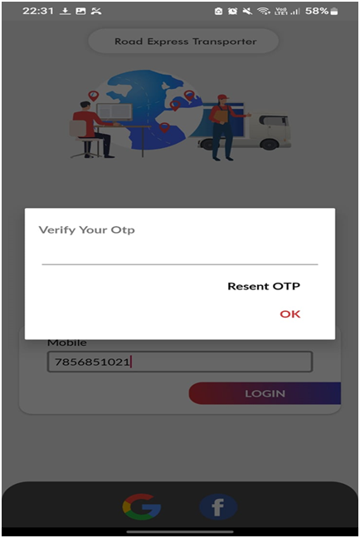

Fig: 6.4.1 :Login with OTP Verification

* **Register themselves(add own information)**

* After Mobile Number Verification the transporter must first provide his / her basic details as Snaped for accessing and managing the further process.

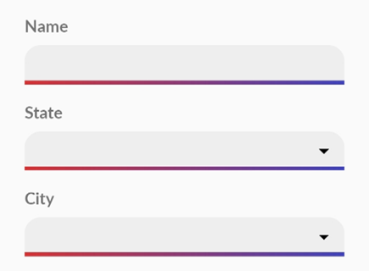

Fig :6.4.2.Registration Page

* There must be Valid and Authorizable documents for the security purpose and also for maintaining the genuinity of the Transporter as She / he has to handle many responsibilities.

* Here all the Snaped fields are Compulsory and Admin will finally Cross Verify the Genuinity of all the uploaded documents.

Fig 6.4.2.3 :Registration page Continue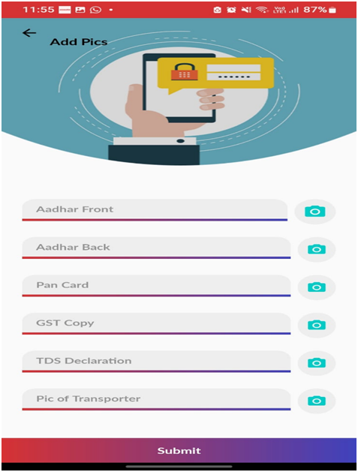

* **Transporter Home screen with add Driver,Vehicle and map info:**

* After all fields have been filled and verified, Transporter Home screen will be Visible as snapped where there are some quick access tools like Add any New Driver, add any New Vehicle Information or want to map any Driver as respected to any Specific Vehicle.

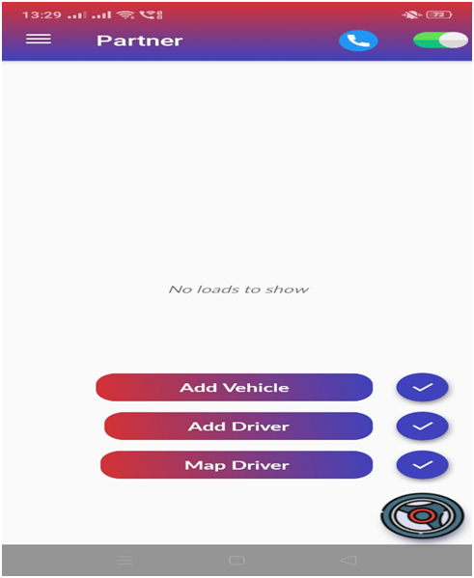

Fig 6.4.4 :Transporter Home screen with Add info

* **Transporter left side toggle with profile and info:**

There is a left side toggle option which is carrying all the details which would be adequate for a Transporter like their Profile Detail, All the three Quick Access Tools, along with them new load Options, Proof of Deposit (Under Construction), Reviewing Options, Able to change their language, All the trips (Trip History, Ongoing Trips, Upcoming Trips), Inviting any friends for increasing public outreach.

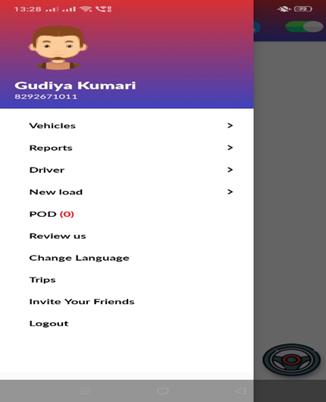

Fig 6.4.5 :Transporter Dashboard

* **Add vehicle info:**

As mentioned, Transporters might have many transporting vehicles and different types. Here they can add as many vehicles as they want.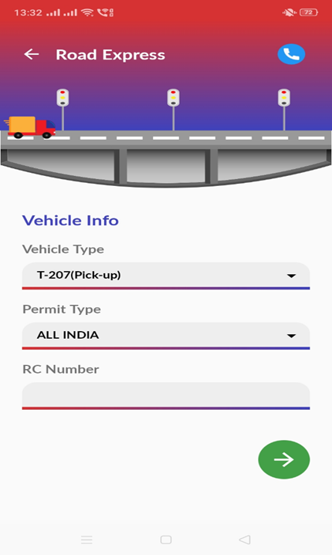

Fig 6.4.6 :Vehicle info

* **List unverified vehicle:**

* But all the vehicles will be enlisted in the Unverified list as there must be Cross Verification of the Vehicle Credentials by Admin Side. Admin will verify all the details by Admin Dashboard

and after that the vehicles will be Verified and be able to run for trips.

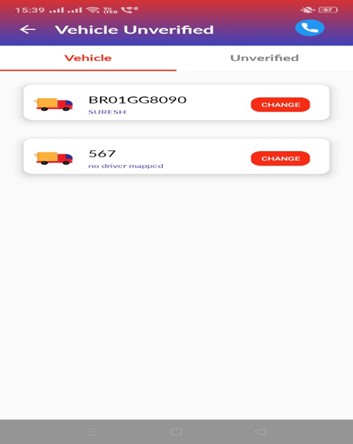

Fig 6.4.7 :Unverified list

* **ADD Driver info:**

* When Vehicles have been added, now it’s time for their respective drivers to be enlisted. On the first page there are basic information fields which will be filled as per their authentic ID details and all the fields are Mandatory.

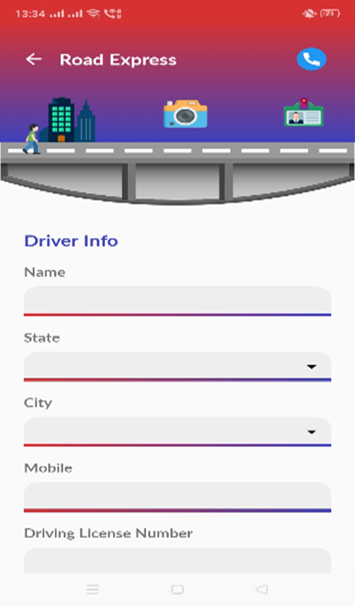

Fig 6.4.8 :Unverified list

* **For confirming the map driver:**

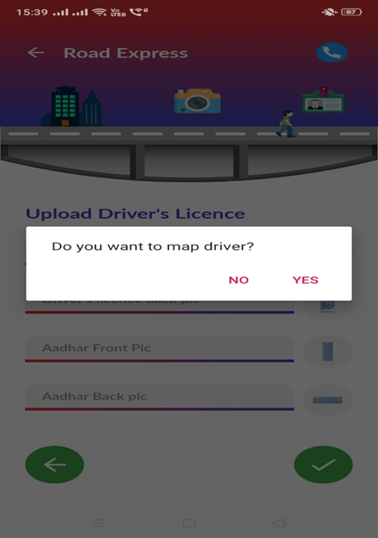

Fig 6.4.9 :Unverified list

* **For change unverified driver list:**

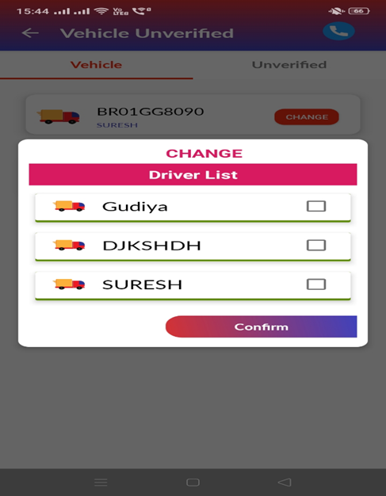

Fig 6.50 :Unverified list

* **Upload Driver’s license Details:**

* The driver will provide his Driver’s Licence and Aadhar Card for maintaining security and Genuity and after the uploading process there must be a validation process by Admin Side and after that any Person will be registered as authentic driver.

Fig 6.51 :Upload Driver’s License Details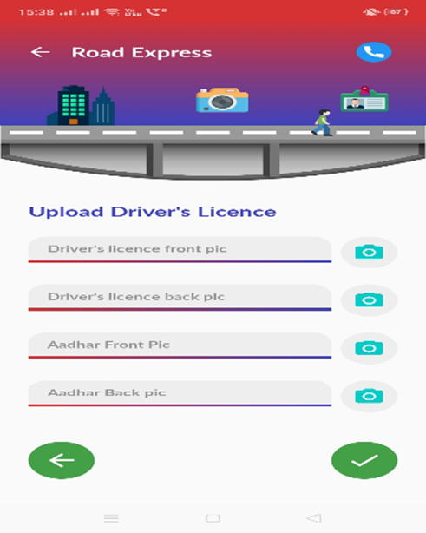

* **Upload Profile pic:**

* There Must be a Profile Picture of driver in Transporter Application for maintaining the records.

Fig 6.52 :Upload Profile pic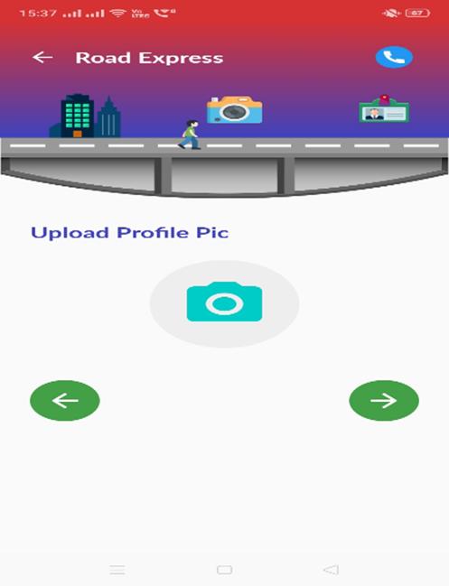

* **For confirming the map driver:**

* There might be possibilities of the driver that some of them could drive only any specific vehicle, then he should be matched with each .

.



Fig 6.53 :Confirm for map Driver

* **For change vehicle unverified list:**

* Here in the below snap, transporter will be able to select the unallocated drivers for any specific vehicle and the driver has already been allocated then transporter has the authority to reallocate drivers.

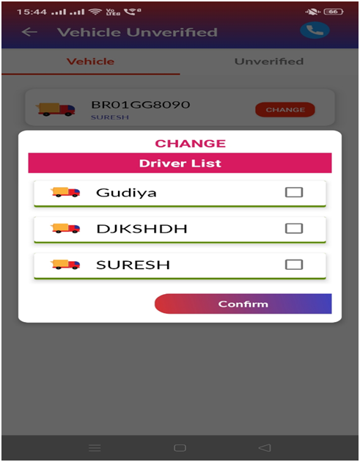

Fig 6.54 :Change vehicle unverified list

* **Done add process:**

* Here, all the updating and validating process will be finished, now Transporter will manage all the process by himself and if necessary to add any vehicle or any driver, then it will be done as mentioned above.

Fig 6.55 :Done Vehicle and Driver process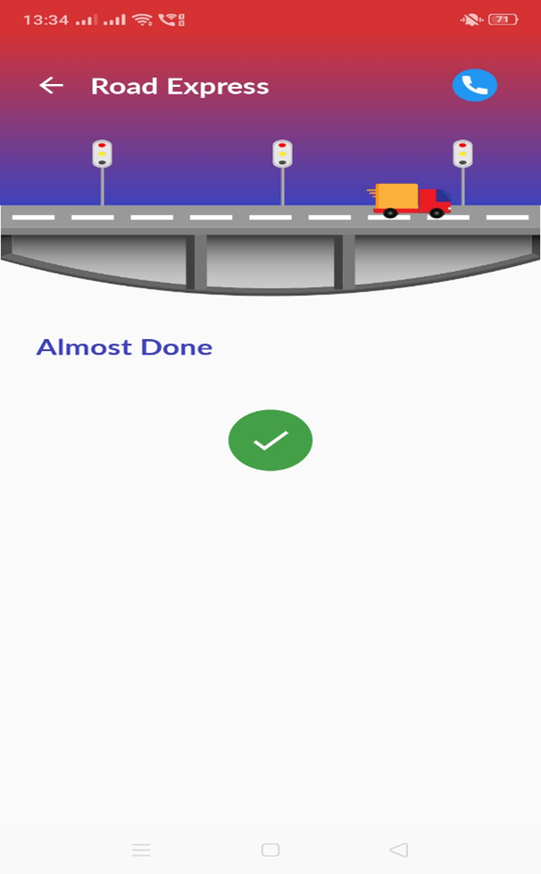

**ROAD EXPRESS HERO APP(DRIVER APP):**

* **Login Driver themselves:**

* This is the first page of Driver’s Application (Road Express Hero) where the driver will initiate his process by tapping on the LOGIN button and by doing this, further steps will be enlisted and visible.

Fig 6.56 :Login Driver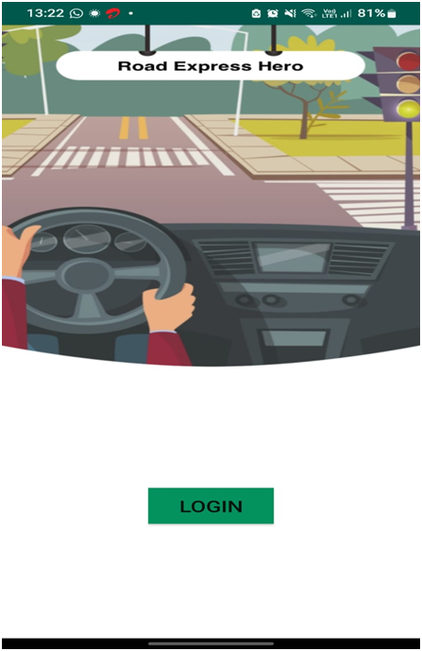

* **Verify OTP:**

* In the below Snap, drivers will have to provide a Four Digit One Time Password which will be sent on their registered mobile number and if they are facing any technical issue then there is an option for Resending the OTP and the OTP will be valid only for 10 minutes.

Fig 6.57 :Verify OTP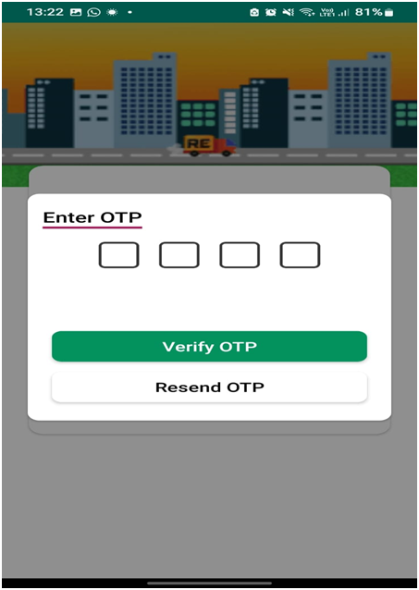

* **Change language:**
* As some of the drivers will not be able to communicate in English Language. So, there is an option of changing the application language to Hindi for convenience.

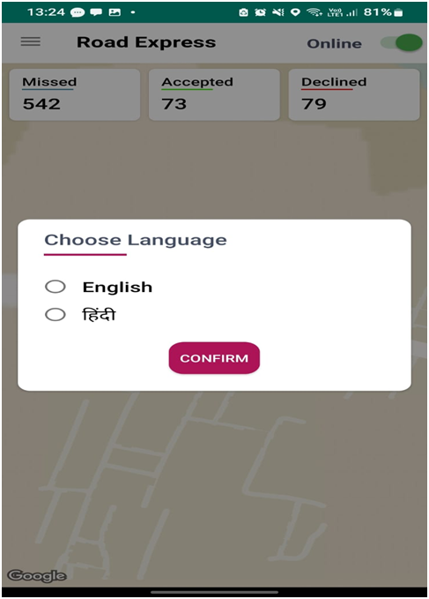

Fig 6.5.8 :Change language

* **Map driver location:**

* As snape, this is the Home Page of Driver’s Application which is containing some of the basic details like Total Missed Trips, Total Accepted Trips, and Total Declined Trips. And also, drivers have the authority to mark themselves as Online or Offline just by Tapping the Top Right Toggle tool.

Fig 6.5.9 :map driver location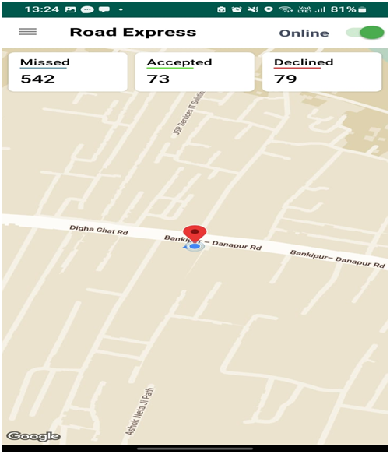

* **Driver’s License info:**

* Here Driver will provide all the required information related to their background like Driver’s Licence, Aadhar Details and Vehicles Registration Details if the drivers have already been allotted with their specified vehicles.

Fig 6.6. :map driver location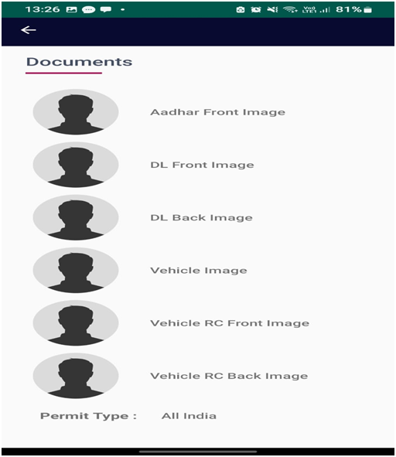

* Here, there are some quick access tools for the convenience of the drivers.
* **Payment Details:**

 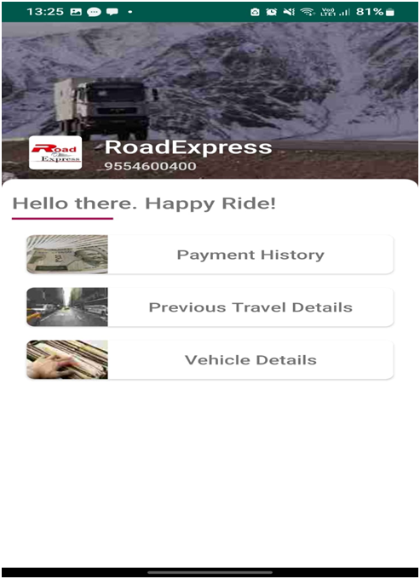

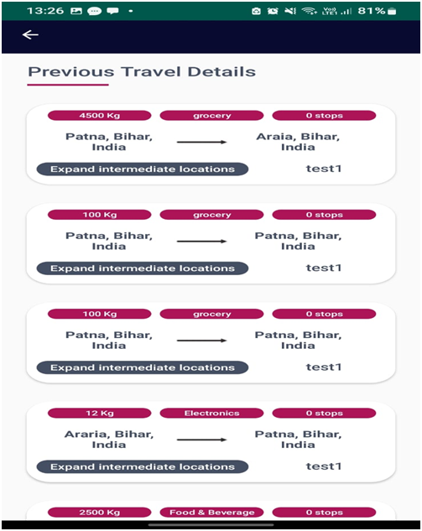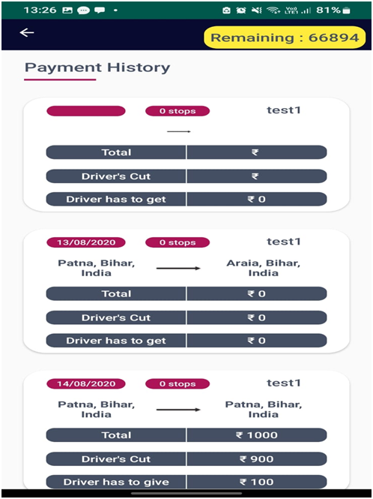

* All the details mentioned here are the history of travel details mentioned in driver’s application for maintaining the travel records for further inspections

* Here all the payment details will be mentioned along with the payment history where all the driver payment centric information will be visible, and the driver will get their incentives / salaries according to this information men

**ADMIN DASHBOARD:**

* **Admin Dashboard Login:**

* As snape, this is the main (Login) page for Administrator where the credentials will be Hard Coded and will be provided to whoever will maintain the admin access. There will only be one Admin credential means to check the security breach there will not be Multi - Admin Access Authority.



* **Admin Dashboard menu:**

* Whole Admin Access UI / UX had been developed using HTML, CSS & JS(Server Side).

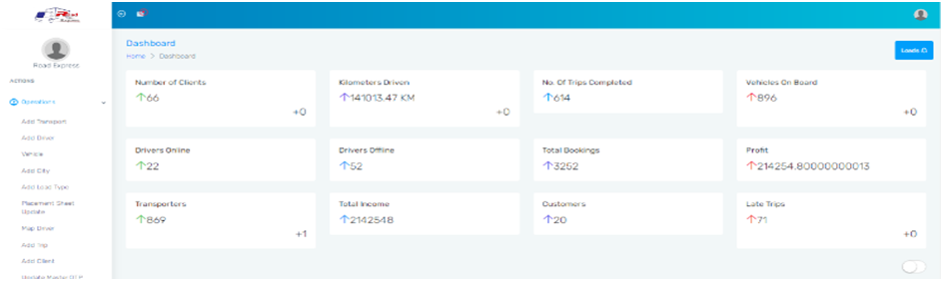

* After successful login, Admin Home Page will be seen as Snaped, and all the vital information will be accessible.

* The Overall details (Total Clients add to this app, Total Kilometres Driven by all vehicles added and managed by respective app or directly added by admin, Total Number of trips completed till date, Vehicles Onboard, Number of online drivers while Admin Login, Number of offline drivers while Admin Login, Total Bookings till now, Profits, Total Transporter Added) with symbolic information which helps admin to keep track of all related situation.

* As snaped above and below, they indicate that all Workflow / Data Flow (Actions) and functionality of every module as well as sub-modules will be described minutely in the “Product Function” Section.

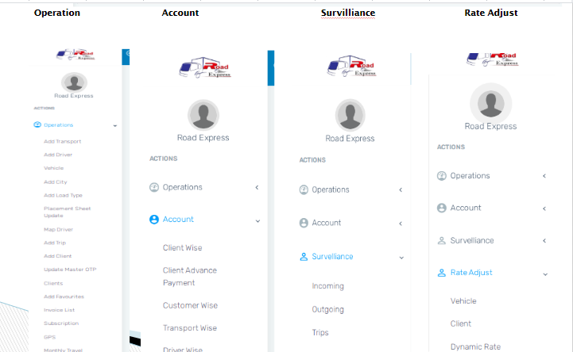

**7. SYSTEM FEATURE**

**7.1 SAFETY AND SECURITY REQUIREMENT**

* Password requirements - Length, Special Characters, Expiry, Recycling Policies, 2Fa.
* Inactivity timeouts - Duration, Action, Traceability .
* Encryption (data in flight and at rest) - All external communication between the system’s data server and clients must be encrypted .
* Data classification/System Accreditation All Data must be protectively marked and stored/protected.

**7.2 SOFTWARE QUALITY ATTRIBUTES**

The quality of the application is maintained in such a way so that it can be very user friendly to all the users.

The software quality attributes are assumed as under:

* + - Accurate and hence reliable
    - Secured
    - Fast speed
    - Compatibility

**8.CONCLUSION**

The major aim with which this project was started was to facilitate the Transporters (Users) to directly connect with Customers for maintaining transparency between all the processes performed during Loading of any heavy-duty products till the Unloading completes as these Goods import or export from different districts or may be from different states.

The traditional way of transportation has many ambiguities related to tracking / Managing Drivers / maintaining rates and 27 X 7 Assistance of products and many times Misguided / Mistraced products affect market rate. Here, our idea “Road Express” will play a vital role in managing all these issues swiftly and easily.

While developing and researching Articles / Theses we found that many drivers don’t have smartphones, they use bar phones as they travel for many days. Then our team found a solution that our application will also track with the help of Sim Card.

This is an Android based Application having Node JS as backend and a Web Based Administrator Panel for maintaining the authority / security / durability of this application.

**9.REFERENCES**

# 

* <https://nodejs.dev/learn>
* <https://firebase.google.com/?gclid=Cj0KCQjw-JyUBhCuARIsANUqQ_IH92yugaGZ-Y56dIX6v1S1gpg51MnfIiqCLqJXFF57HNQ800lmWTEaArHXEALw_wcB&gclsrc=aw.ds>
* <https://www.freecodecamp.org/news/html-css-and-javascript-explained-for-beginners>
* <https://www.mysql.com/>
* [https://play.google.com/store/apps/details?id=com.ilya bogdanovich.geotracker&hl=en_IN&gl=US](https://play.google.com/store/apps/details?id=com.ilyabogdanovich.geotracker&hl=en_IN&gl=US)
* <https://morth.nic.in/signature-project>

# 

# Annexure

# USE CASE DIAGRAM:

Use case diagrams were used to gather the requirements of a system including internal and external influences. These requirements were mostly design requirements. Hence, when a system was analyzed to gather its functionalities, use cases were prepared and actors were identified. When the initial task is complete, use case diagrams are modeled to present the outside view.

A use case diagram is used to represent the dynamic behavior of a system. It encapsulates the system's functionality by incorporating use cases, actors, and their relationships. It models the tasks, services, and functions required by a system/subsystem of an application. It depicts the high-level functionality of a system and also tells how the user handles a system.

This is the sketch of the user’s interaction with a technology that describes the relationship among the user and various tasks in which the user participates. A use case diagram contains actors, use cases, and a boundary. Boundary refers to the system of interest, actors are the individuals that interact with the technology, and use cases are the specific tasks of actors.

**Following are the purposes of a use case diagram given below:**

1. It gathers the system's needs.
2. It depicts the external view of the system.
3. It recognizes the internal as well as external factors that influence the system.
4. It represents the interaction between the actors.

**Element:**

A use case diagram captures the business processes carried out in the system. Normally, domain experts and business analysts should be involved in writing use cases. Use cases are created when the requirements of a system need to be captured. A use case diagram is quite simple in nature and depicts two types of elements: one representing the business roles and the other representing the business processes. Let us take a closer look at what elements constitute a use case diagram.

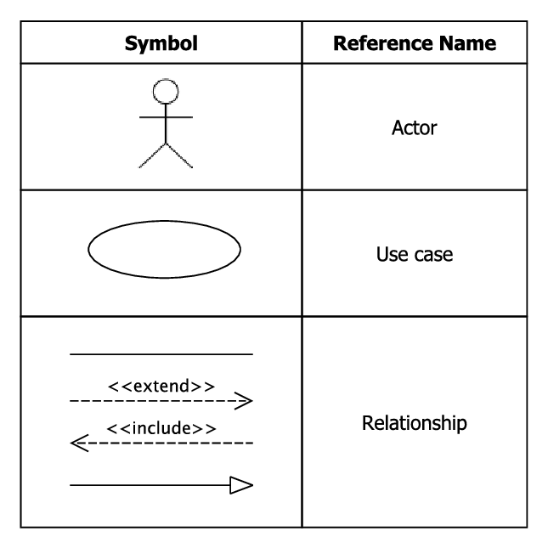

**One Extra Element: System Boundary**

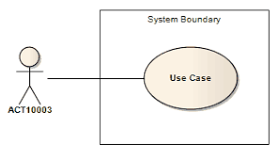

**Actor:**

An actor portrays any entity (or entities) that perform certain roles in a given system. The different roles the actor represents are the actual business roles of users in a given system. An actor in a use case diagram interacts with a use case.

**For example**:According to our application use case diagram the Admin ,Transporter ,Driver and Client are actors of the use case diagram.

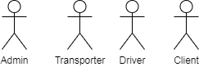

fig:Actor of the Use Case Diagram

**Use Case:**

A use case in a use case diagram is a visual representation of a distinct business functionality in a system. The key term here is "distinct business functionality." To choose a business process as a likely candidate for modeling as a use case, you need to ensure that the business process is discrete in nature. As the first step in identifying use cases, you should list the discrete business functions in your problem statement. Each of these business functions can be classified as a potential use case. Remember that identifying use cases is a discovery rather than a creation. As business functionality becomes clearer, the underlying use cases become more easily evident. A use case is shown as an ellipse in a use case diagram.

**For example:**According to our application use case diagram these all are the main use cases in use case diagrams.

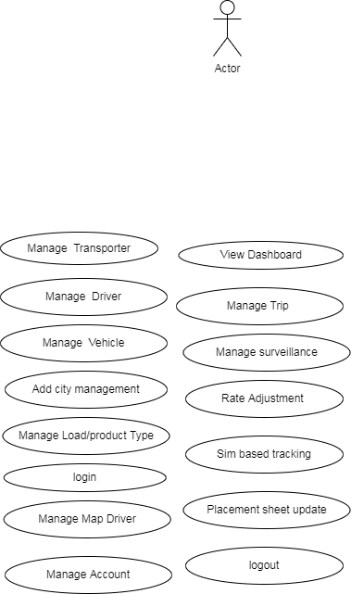

fig: Use Case in a Use case diagram

**Relationship:**

Use cases share different kinds of relationships. A relationship between two use cases is basically a dependency between the two use cases. Defining a relationship between two use cases is the decision of the modeler of the use case diagram. This reuse of an existing use case using different types of relationships reduces the overall effort required in defining use cases in a system.

Use case relationships can be one of the following:

* **Include:** When a use case is depicted as using the functionality of another use case in a diagram, this relationship between the use cases is named as an include relationship. Literally speaking, in a include relationship, a use case includes the functionality described in another use case as a part of its business process flow. An included relationship is depicted with a directed arrow having a dotted shaft. The tip of the arrowhead points to the child use case and the parent use case is connected at the base of the arrow. A key here is that the included use case cannot stand alone, i.e., one would not validate the patient record without making an appointment. The stereotype "<<include>>" identifies the relationship as an include relationship.

**For example:**

fig: Include relationship in use case diagram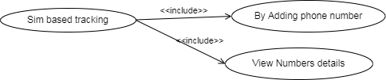

* **Extend:**In an Extend relationship between two use cases, the child use case adds to the existing functionality and characteristics of the parent use case. An Extend relationship is depicted with a directed arrow having a dotted shaft, similar to the include relationship. The tip of the arrowhead points to the parent use case and the child use case is connected at the base of the arrow. The stereotype "<<extend>>" identifies the relationship as an Extend relationship.

**For example:**

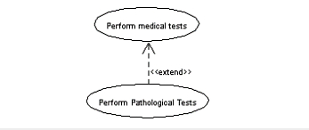

fig:extend relationship in a use case diagram

* **Generalizations:** A Generalizations relationship is also a parent-child relationship between use cases. The child use case in the generalization relationship has the underlying business process meaning, but is an enhancement of the parent use case. In a use case diagram, generalization is shown as a directed arrow with a triangle arrowhead. The child use case is connected at the base of the arrow. The tip of the arrow is connected to the parent use case.On the face of it, both generalizations and extends appear to be more or less similar. But there is a subtle difference between a generalization relationship and an Extend relationship. When you establish a generalization relationship between use cases, this implies that the parent use case can be replaced by the child use case without breaking the business flow. On the other hand, an Extend relationship between use cases implies that the child use case enhances the functionality of the parent use case into a specialized functionality. The parent use case in an Extend relationship cannot be replaced by the child use case.

**For Example:**

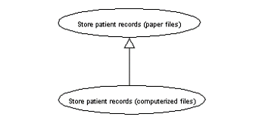

fig: Generalizations relationship in use case diagram

* **System boundary:** A system boundary defines the scope of what a system will be. A system cannot have infinite functionality. So, it follows that use cases also need to have definitive limits defined. A system boundary of a use case diagram defines the limits of the system. The system boundary is shown as a rectangle spanning all the use cases in the system.

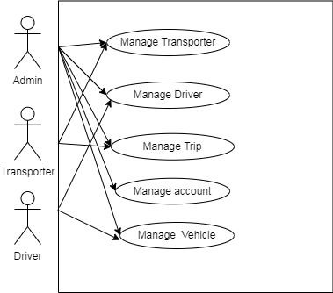

fig:System Boundary in Use Case Diagram

**Overall Complete Use case Diagram of our road express application**





